ANSWERS 2013 MUSICIANSHIP PAPER
Q1a | Option 4
Q1b | Option 2
Q2ai | Bar 2
Q2aii | 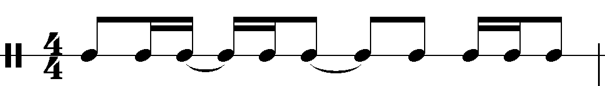
Q2aiii | Simple Quadruple
Q2bi | Bar 1
Q2bii | 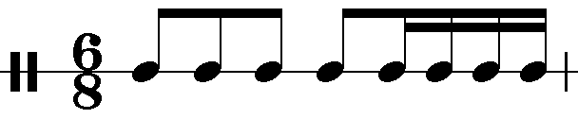
Q2biii | Compound Duple
Q2ci | Bar 4
Q2cii | 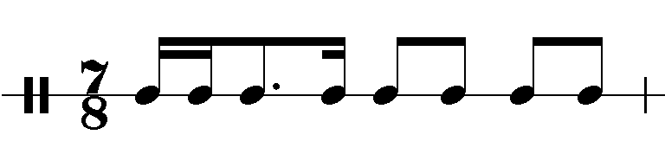
Q2ciii | Irregular
Q3a | 2/4 time
Q3b | 5/8 or 5/4 time
Q4
Q5a | Option 1
Q5b | Option 3
Q6a | Perfect 4th
Q6b | Minor 3rd
Q7a | Minor 7th
Q7b | Augmented 4th (Diminished 5th, Tritone)
Q7c | Major 2nd
Q8a
Q8b
Q8c
Q9a | Option 3
Q9b | Option 2
Q10ai | Major
Q10aii | 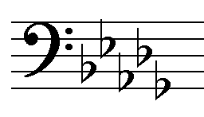
Q10bi | Minor
Q10bii | 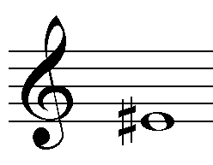
Q11a | Option 2
Q11b | Option 1
Q12 | 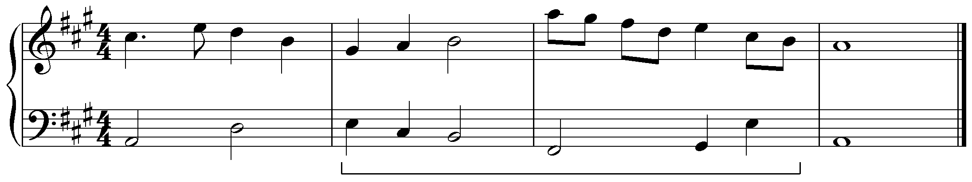
Q13
Q14a | B minor triad in root position, or i in B minor
Q14b | Eb/G, or Ib in Eb major
Q14c | C half-diminished seventh, or ii7 in Bb minor
Q15a | Option 1
Q15b | Option 2
Q16a | 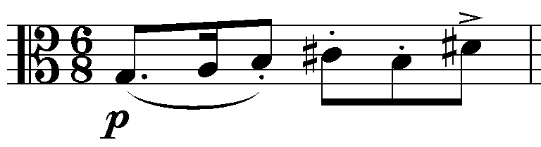
Q16b | Ab augmented triad , or Ab⁺
Q16c | Option 2
Q16d | Option 1
Q16e | Option 3
Q16f | fortissimo, very loud
Q16g | chromaticism
Q17a | Eb major
Q17b | Option 1
Q17c | C minor, relative minor
Q17d | Option 3
Q17ei | Ab, or IV in Eb Major
Q17eii | Eb∆, or Eb major 7, or I7 in Eb Major
Q17f | Option 3
Q18a | Option 3
Q18b | tenuto, staccato, marcato(or accent)
Q18c | Option 4
Q18d | Eb major
Q18e | Option 1
Q18f | Perfect unison
Q19
Q20ai | Perfect Cadence
Q20aii | Imperfect Cadence
Q20aiii | Plagal Cadence
Q20b | Six possible passing notes – any 4 correct  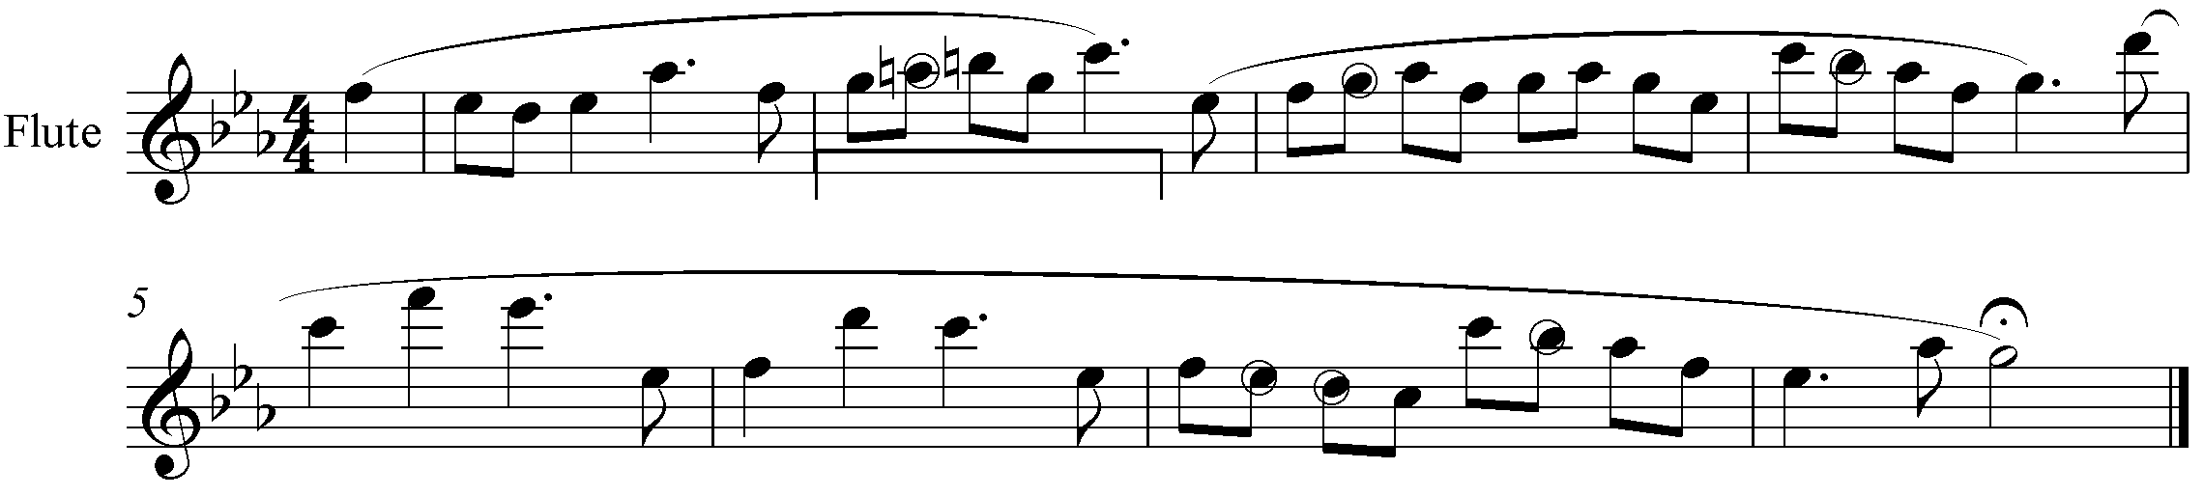

Q21 POSSIBLE CORRECT ANSWER
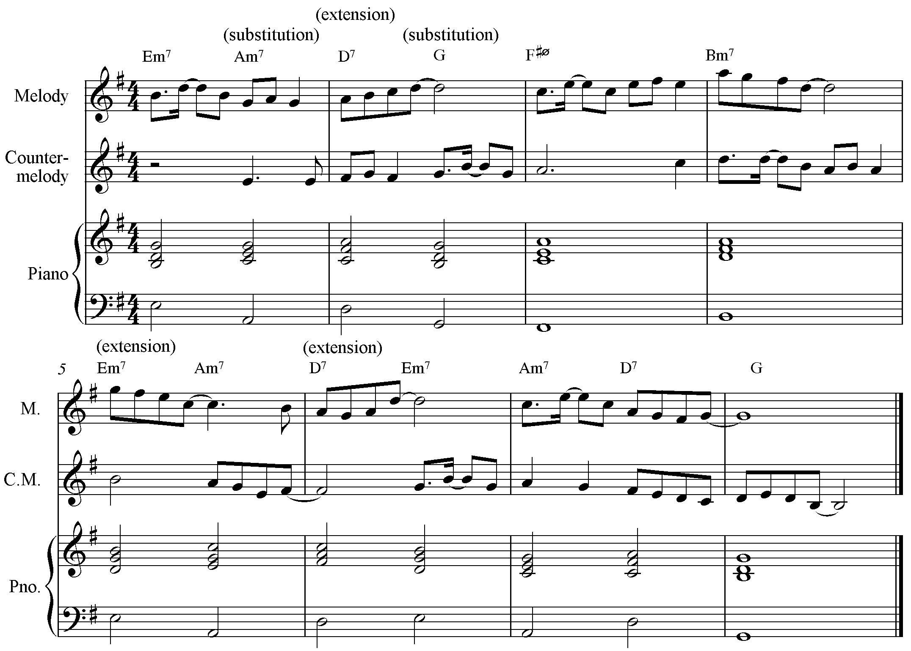
Q22 POSSIBLE CORRECT ANSWER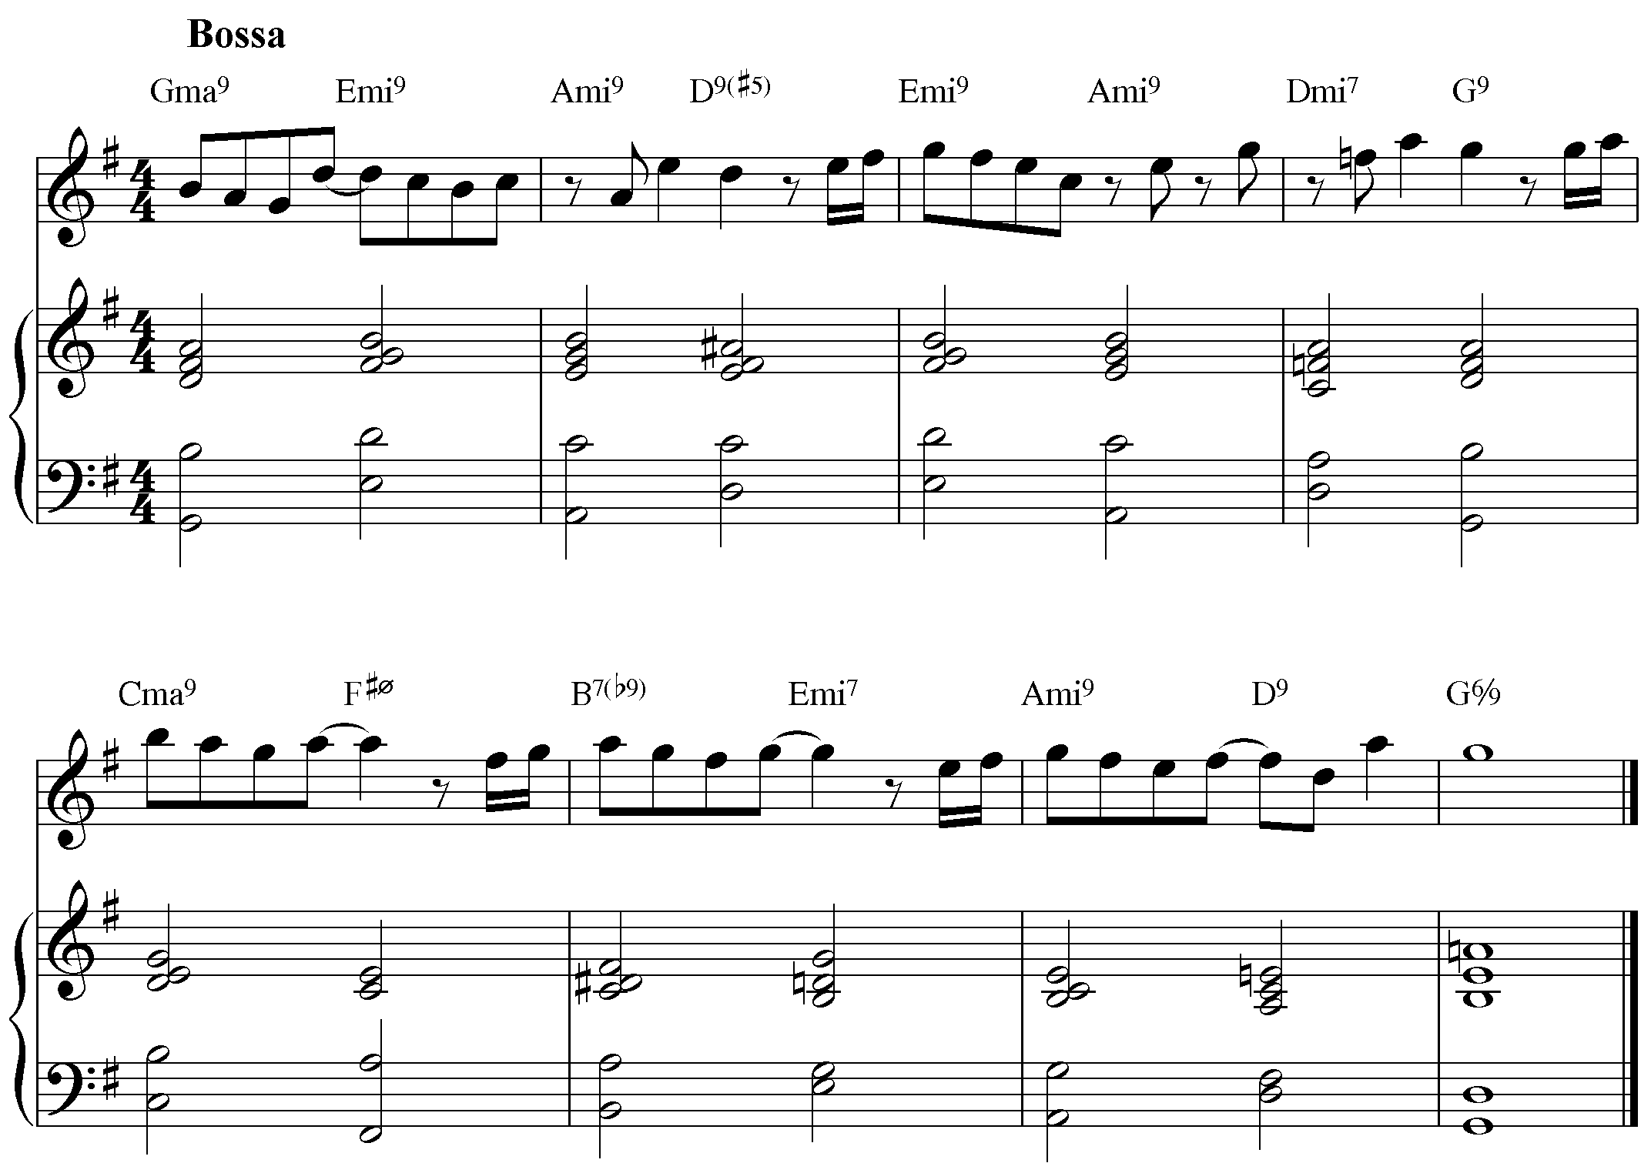
Q23 POSSIBLE CORRECT ANSWER
