Music Studies 2019 Possible Answers
These answers are not approved by SACE. They have been put together by Penny Mansell and Virginia Lakeman as a guide to teachers and students. Accompanying these written answers are Sibelius files of the creative and harmony questions. Where a variety of answers are possible each has been over answered. Students are encouraged to give as many points as there are marks allocated to the question.
- (a) Option 2
(b) Option 1
(c) Option 3 - Diminished 7th Chord
(d) Option 4 – compound triple time (9/8)

- Completed rhythm
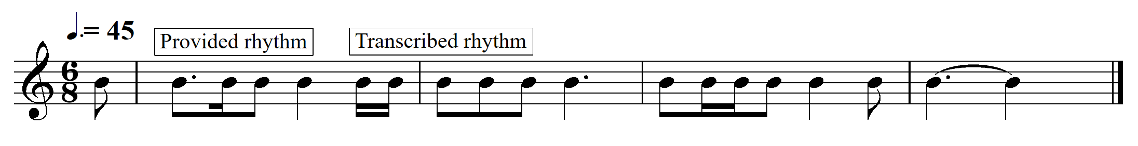

- (a)
    - Minor 2nd 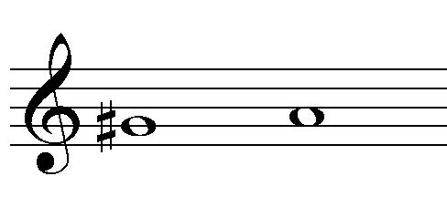

    - Major 6th 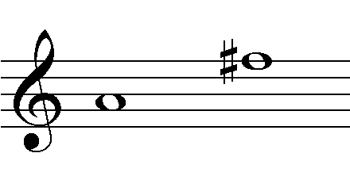

- (a) Option 4 – Natural minor scale
(b) Option 1 – Blues scale

- Completed oboe part (melody)
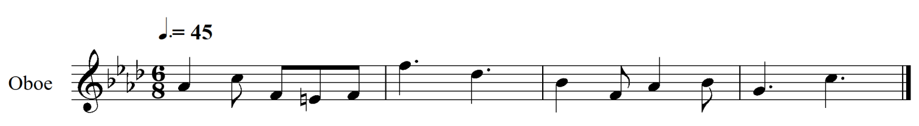
- Imperfect cadence (4-5) (Bb min – C maj) / (ivb – V) in F harmonic minor
- Mediant / 3rd is note marked (i)

- Option 3 (I – ii – V7 – I – vi) (D – Em – A7 – D – Bm)

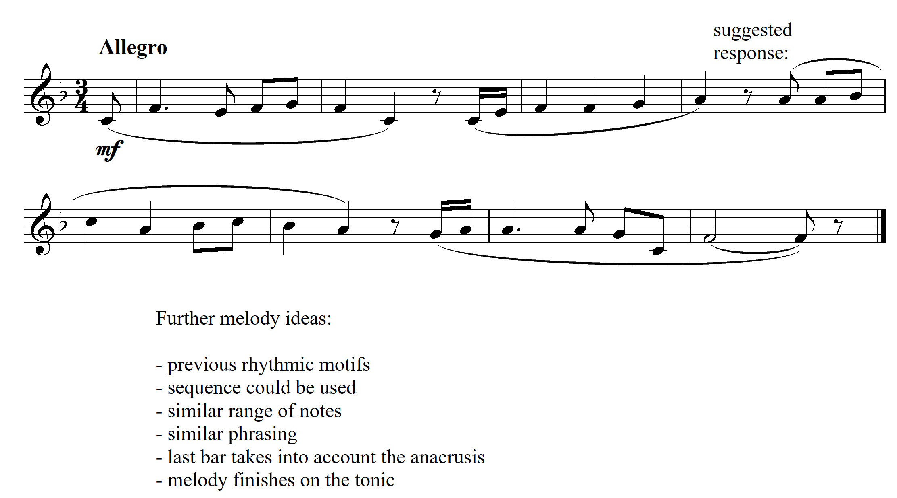

(a) Intro – Ternary Form – Outro/ Coda
(Intro = bars 1-2) (A section = bars 3-14) (B section = bars 15-26) (A section = bars 27-38) (outro / coda = bars 39-40)
(b)
- STYLE – quavers are to be swung
- TEMPO – crotchet = 130 crotchet beats per minute
- ARTICULATION – staccato = short and detached

- Suggested answers: (any three)
Swing, 12 bar blues using 145 chords
Syncopated rhythms
Use of 7th chords
Stab chords
Call and response
Stylistic articulations
Left hand piano alternation between two perfect 5th chords and two major 6th chords in the A section, then the use of triplets in the B section.
Melodic phrases beginning on the weak part of the beat (The part of the beat that is usually slightly emphasised in swing style)

  - Option 2 – Dorian
  - Option 3 – Mixolydian

- Quavers are played straight (not swung)
Right hand piano and Alto sax play unison rhythm which is a new feature of the piece.
The rit. continues from bar 38, therefore these bars are slower than the rest of the music.

- (a) B section contrasts with timbres (DJ turn table used as percussion)
(b) The short intro uses irregular meters, the rest of piece is in 4/4 (Common time / simple quadruple)
Time Signature = 4/4 (Simple Quadruple)
Tempo = approx.. crotchet = 80
Rhythmic patterns = use of triplets, ties to created syncopated rhythms, synth clap timbre emphasis 2 and 4, Bongo plays 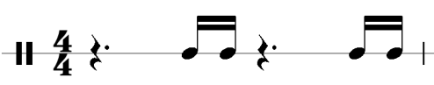repeated pattern.

(c) synthesized sounds, swells, stark dynamic contrasts, steady beat
(d) Most timbres are produced with a synthesizer. Synthesized bass and keys, mellow pad synth timbres, DJ turntable / vinyl scratching, percussion has an Indian / Raga effect with the bongos and finger cymbals B section and small tone blocks in the A section which sound acoustic).

- Option 3

11. (a) The meter is changed from simple triple ¾ to simple quadruple 4/4. Each phrase of the melody is reduced to 3 bars allowing musical ‘fills’ in the fourth bar (piano has the fill in bars 8 & 12 and trumpet in bar 16)
(b) More complex jazz chords. The tonic Bb has been replaced by the relative minor chord 6m7, Gm7. Eb from original is replaced by Abmaj7, (b7maj7). F7 replaced by A13 a chord extension. Bar 8 has Bb7#9 that uses the altered #9.
(c) Bar 16 the trumpet has the ‘fill’ – a copy/repeat of the piano bar 8. Bars 13 – 15 the tenor sax. has the melody from bar 5 – 7 with minor changes – the minim becomes a pair of swung quavers in the ‘be bop’/ ‘re bop’ articulation of long short, answered then later supported by the trumpet.
(d) The ride cymbal has the typical swing rhythm, the upright bass has a walking line of crotchets typical of swing. The piano rhythm also has features of swing – minim on the beat, then quaver rest, crotchet and tied quaver to beat 1 of the next bar.
(e) (i)
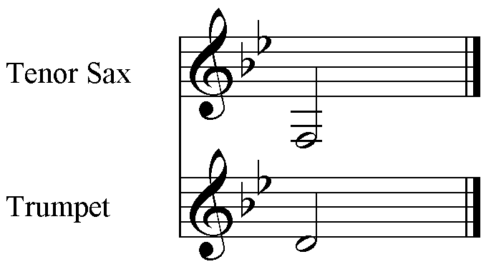
(ii) major 6th
12. (a)
(i) Ternary form (with an introduction and short coda)
(ii) Theme and Variation
(b)
(i) Cm/G Fm7 Bb7/F Eb (6m 2m7 57 1)
(ii) Em C F#o B (1m 6 2o 5)
(c) A day in Montmartre – accompanied melody throughout
Threads of Difference – Bars 1 – 36 – accompanied melody. Bars 37 – 43 – polyphonic with 3 melodic lines. There are imitative entries in bar 37 and bars 41 – 42. Bars 21 – 28 mainly feature a homophonic texture with the accented chords in rhythmic unison.
(d) A day in Montmartre – Simple triple throughout in the style of a waltz. The quaver subdivision or the beat features mainly with the exception of bars 18 – 29, 33 – 34, 50, and 52 – 54. The dotted minim bass followed by chords on beats 2 and 3 each bar except bars 30 – 34, bars 43 – 45 where the chords are replaced by 5 quaver chords, and bar 51 maintain the waltz feel.
Threads of Difference – has more varied rhythm. The cello theme bars 1 – 4 has some rhythmic variety and is accompanied by bowed tremolo demi-semi-quavers from violin and viola. Bars 5 – 11 feature a syncopated chordal accompaniment from the viola. Bars 13 – 19 features a triplet accompaniment against sustained minim tied to a quaver in the dialogue between violin and cello. There are changes in meter 4/4, 7/8. 6/8. The allegro 7/8 is grouped 2, 2, 3 bars 21 – 27. The Andante 6/8 has a quaver accompaniment divided between viola and cello to the violin melody that makes semiquavers a feature.

