Music Studies 2020 examination answers
1. (a) 2nd option
(b) 3rd option (C Dorian)
(c) 4th option (notes A C# E# G
2.
3. (i) Perfect 5th
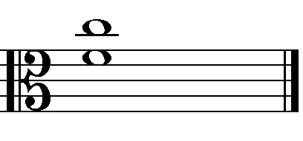
(ii) Minor 7th
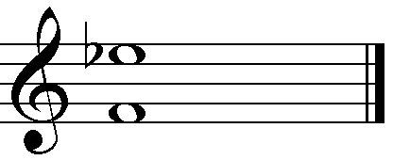
4. (a) Option 1.
(b) Option 3.
5. 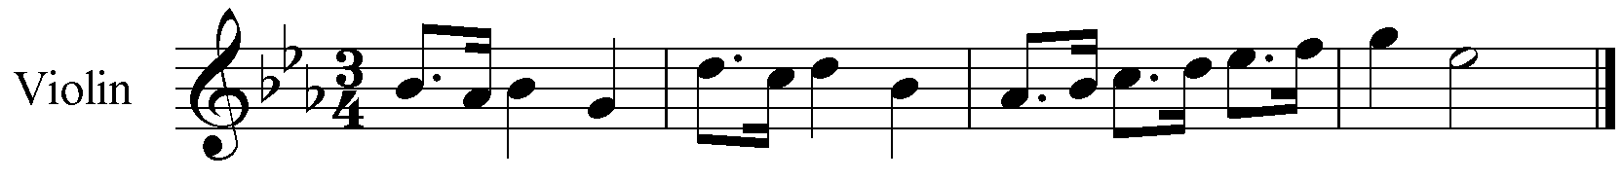
(a) Plagal, IV – I
(b) Subdominant
6. Option 4
7. Various – Suggestion only
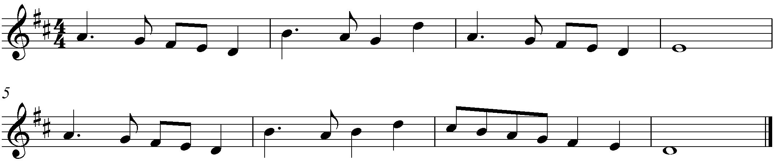
8. Structure
Introduction bars 1 – 4 Tonic key F major
A bars 5 – 20 divided into two parts bars 5 – 12 and bars 13 – 20
B bars 29 – 36 in F minor
A beginning with a variant of the introduction 37 – 40 in the tonic F major Bars 41 – 44 is from bars 5 – 8 with a slightly varied accompaniment.
Coda bars 45 – 51 (end)
(b) (i) A pause – hold for as long as you like, or as long as a conductor directs.
(ii) A triplet – the three notes are to be played in the time of two of the same value.
(c) Option 1 – Natural minor
(d) The clarinet from bar 29 – 32 sounds at the same pitch as the upper notes from the right hand of the piano at bars 33 – 36.
(e) (i) F major
(ii) F minor
(iii) Tonic minor (an example of modal exchange)
(f) Option 2
9. (a) (i) Section A uses a free rhythm that has rapid figures, long sustained sounds/pauses and moments of silence/rests.
(ii) Section B uses a regular rhythm which is layered above option 4 question 10, a one bar rhythmic pattern that is repeated to make a four bar unit.
(b) (i) Section A is monophonic, that is the flute is unaccompanied. The timbre is varied using a range of techniques:- forceful tonguing, long reverberation time (reverb.) in the recording, vibrato, flutter tonguing.
(ii) Section B is multilayered using looping technology. One part is recorded then as it is played back another is added. All parts are played with standard techniques of tone control in contrast to the extended techniques used in the A section. The recording is ‘dryer’ having less reverberation time (reverb.).
10. Option 4
11. (a) The rhythm of the original 4/4 melody in crotchets has been changed to a 7/8 time with a minim followed by a dotted crotchet.
(b) (i) Viola
(ii) First violin
(iii) Second violin
(c) The violoncello supplies a quaver arpeggiated chord accompaniment with accents on the first and fifth quaver to supply the rhythmic drive. The repeated D in every bar in this passage is a tonic pedal.
(d) (i) pizz. stands for pizzicato the technique of plucking the strings
(ii) arco means use the bow
(e)
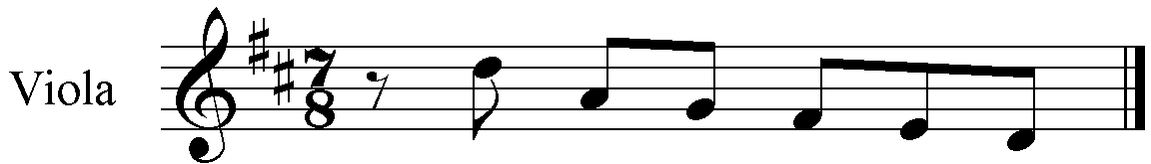
(f) D Bm Em A That is I, vi, ii, V
12. (a) The Fanfare is polyphonic, using counterpoint between trumpet 1 & 2 in bars 1 – 14 and between all three instruments at bars 15 – 24. There is a sustained chordal accompaniment bars 6 – 14 and a final homophonic section from the piano bars 26 – 27.
Threnody’s opening bar and bars 21 – 23 have a homophonic texture. Some moments feature an accompanied melody such as bar 2, and most obviously in bars 5 – 13.
(b) The Fanfare is mainly in 4/4 meter but with 2/4 used at cadence points, bars 5, 10, 23 & 25. Triplet subdivisions of the beat are a feature as are acciaccaturas (crushing notes – very short notes with a decorative function).
Threnody features the quaver as the main subdivision of the beat. Initially there is one bar of 4/4 followed by two bars, then three bars of 6/8. Later 7/8 is found in bar 9 and ¾ in bars 17, 20 – 23 and 27 – end. There is some use of syncopation in bars 24 – 25.
(c) Fanfare features imitation between trumpet 2 and the piano in bars 19 – 21. A canon between trumpet 1 and 2 is found in bars 15 – 17 with trumpet 2 a 4th lower.
Threnody uses staggered entries bars 1, 4 & 8, with a similar feature, though with long notes, in bar 15. There are parallel 5ths between the bassoon and flute in bar 11 – this has the effect of changing the tone colour.

13. Possible answer
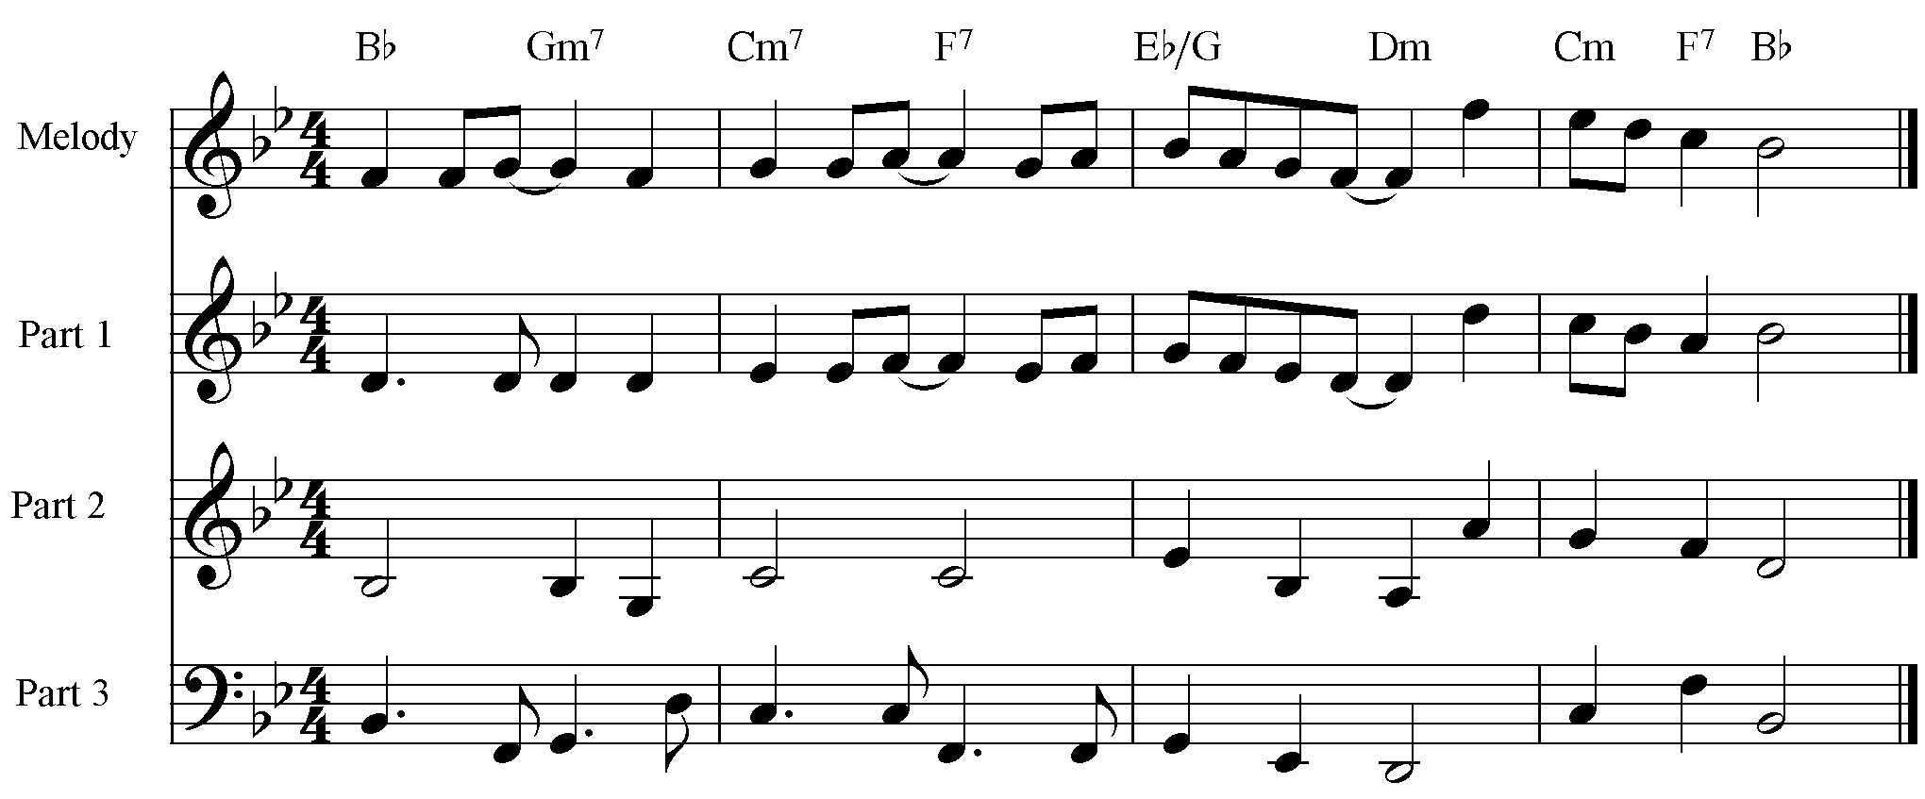14.
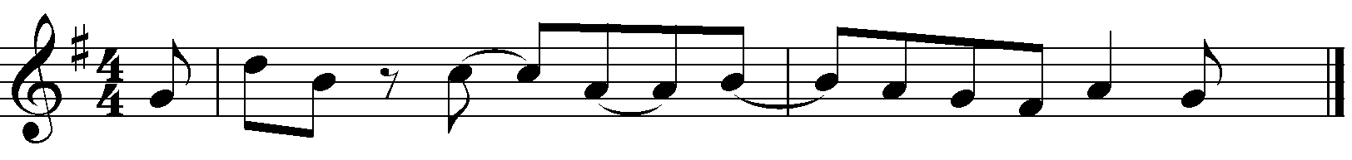
15 Option A Possible answer
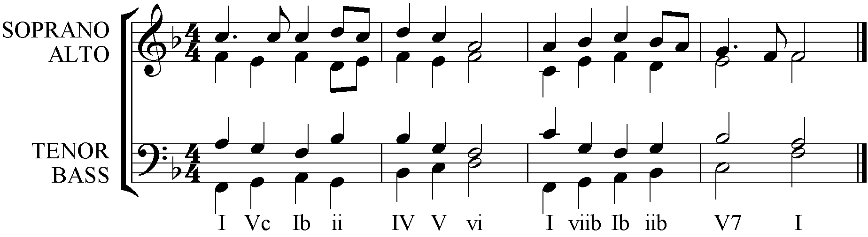
15 Option B Possible answer
