Work Integrated Learning Policy

Authorised By: | Academic Board | Revision: 2.3
Last Amendment Date: | Revision Date: 03 Feb 2022
Review Due Date: | Next Review: 03 May 2024
Related Documents: | Notification of Concern  Suitability for Professional Experience Placement  Student Grievance  Students in the Workplace
Responsible Officer: | Registrar
Review: | Academic Quality Assurance Committee

Any person who requires assistance in understanding any aspect of this document should contact the Responsible Officer

- Overview
The purpose of this policy is to establish the framework for the inclusion of Work Integrated Learning (WIL) in Tabor’s courses and establish the principles through which the College’s staff administer its programs of WIL placements for students. This policy is supplemented by faculty-specific handbooks, which lay out in greater detail the WIL requirements of and procedures for Tabor staff, students and stakeholders.
The over-arching purpose of Work Integrated Learning (WIL) at Tabor is to enhance student learning. The College is committed to developing in its students high level skills and attributes that will enhance their transition from higher education to rewarding and fulfilling employment and lifelong learning. To this end, Tabor recognises WIL as a purposeful, organised, supervised and assessed educational activity that integrates academic learning of a discipline with its practical application in the workplace.
WIL is embedded as a formal component of all professional degree courses. Learning activities and work for assessment are specifically designed to require students to integrate and appropriately apply previous learning and knowledge to make and justify decisions in a work-related context. The aim is to ensure that students develop the ability to integrate their learning through a combination of academic and work-related activities. In addition, students are taught and encouraged to reflect upon their own decisions and actions in those work-related activities to critically appraise themselves and their own professional development.

This policy articulates a range of these requirements and expectations and links them to processes and procedures that make the Work Integrated Learning program equitable, accessible, transparent and efficient. In conjunction with the Students in the Workplace Policy and associated faculty-specific WIL handbooks, it provides a comprehensive and integrated approach to WIL, recognising that there will always be a variety of expressions of WIL across study disciplines.
- Scope and Applications
This policy applies to all courses at Tabor College which incorporate WIL as a formal component of the course. Work or work experience which is not a required component of a course or a unit is outside the scope of this policy.
- Policy Principles
General
  - Tabor’s courses are open to all applicants who meet the minimum academic and non-academic requirements for an offer of enrolment.
  - Potential students are notified of the WIL requirements of Tabor courses and application processes are designed to include the consideration of WIL requirements.
  - Tabor will take effective steps to:
3.3.1 monitor the wellbeing of students who are engaged in WIL;
3.3.2 provide educational and other support if needed; and
3.3.3 manage critical incidents should they occur.
3.4. All WIL activities must comply with relevant legislation, College policies and, where appropriate, professional accreditation requirements.
Curriculum and pedagogy
  - WIL activities must meet the following criteria:
3.5.1 be embedded into the course curriculum to enable students to integrate theoretical learning into work-related contexts;
3.5.2 have explicit learning outcomes and assessment related to work practice and professional formation.
  - Where a Work Placement is a required component of a course or unit, the total hours expected of students must be explicitly stated in the marketing material of the course, the Student Handbook for the subject and/or the Subject Description.
Student supervision, assessment and feedback
  - WIL activities must be supervised by an academic staff member, and where they take place in a workplace, collaboratively with a workplace supervisor.
  - The Work Integrated Learning Office in each faculty will ensure students are contacted and supported during the placement.
  - The assessment of WIL must be made explicit, and compliant with the Assessment Policy and professional requirements if relevant.
  - Reasonable adjustments will be made for students with a disability or medical condition.
  - Feedback is the collective responsibility of the Subject Lecturer, the workplace supervisor, and the students. The Subject Lecturer must ensure formal feedback is sought from the workplace supervisor and recorded.
  - Student performance feedback and guidance must be provided in a timely manner throughout the placement.
  - Feedback will be utilised in improving the overall student experience, pedagogical approach and management of the WIL.
Partnerships
  - Tabor recognises the value of its business, industry, government and community partners and seeks to build sustainable partnerships that focus on providing high-quality learning outcomes for students involved in WIL.
3.14.1 Work Placements will be sought that provide a high-quality learning environment and workplace supervision in the partner organisation.
3.14.2 Industry or Community Projects will be sought that provide students with high-quality projects with a real-world application and audience, as well as significant engagement with the partner organisation.
3.14.3 Workplace Simulations will be created that are informed by regular consultation with partner organisations to provide learning environments that are as realistic to the workplace as possible.
Administration of Work Placements
  - The administration of the WIL program is undertaken by each faculty Work Integrated Learning Office and considers, where appropriate and possible, the needs of individual students in relation to personal and academic requirements, geographical location, course requirements, access to transport and resources, background, experiences and circumstances.
  - In approving workplaces for placements, Tabor staff will be guided by the faculty-specific placement checklist and will ensure:
3.16.1 student wellbeing;
3.16.2 student safety;
3.16.3 access to support for students;
3.16.4 compliance with Australian workplace laws including Workplace Health and Safety, Fair Work Australia and related legislation regulations and guidelines (as far as is reasonably possible); and
3.16.5 related matters.
Students are informed of their personal responsibilities for health and safety during WIL activities conducted in professional/work settings.
  - Students may be invited to be proactive in the acquisition of a WIL placement; however, Tabor will provide support and guidance.
  - The procedures and practices of the Work Integrated Learning Office of each faculty reflect course accreditation requirements and mandatory requirements for Students working with children and young people.
  - Each approved workplace will enter a formalised agreement with Tabor which will include clear expectations for the parties involved and outcomes sought for students.
  - The relationship between (including expectations of) the student and Tabor College is codified in the subject description and the relevant faculty handbooks.
  - The College will employ monitoring processes to demonstrate compliance with the agreement, including periodic on-site or electronic contact with students and supervisors.
  - Given the special conditions of work placements, faculties are responsible for:
3.22.1 management of work placements;
3.22.2 preparation of students;
3.22.3 monitoring of progress;
3.22.4 quality assurance of workplaces;
3.22.5 qualifications and suitability of supervisors; and
3.22.6 contractual arrangements.
Roles and responsibilities
  - The College is responsible for providing resourcing to support WIL activities in all faculties including:
3.23.1 professional development;
3.23.2 central resources; and
3.23.3 insurance, including public liability, personal accident, professional indemnity.
  - The faculties are responsible for:
3.24.1 academic workload allocations; and
3.24.2 other staffing
sufficient to ensure adequate student support.
Student fitness for placement
  - Students must comply with all applicable agreements, conditions, codes of practice, professional behaviours, and laws governing privacy or confidentiality in relation to all WIL activities.
3.26. All students participating in work integrated learning:
3.26.1 must have the capacity to safely undertake the inherent requirements of the work integrated learning activities;
3.26.2 must meet the prerequisites for the subject or work integrated learning activity as defined in the subject outline or handbook for the subject or activity; these may include but are not limited to a Police check and current safeguarding children training for any activity involving contact with vulnerable persons;
3.26.3 will sign a self-declaration regarding fitness to undertake the placement or activity;
3.26.4 will act in accordance with Tabor’s Code of Conduct and Student Integrity Policy;
3.26.5 will act in accordance with Tabor’s Guidelines for Professional Conduct (Appendix A)
3.26.6 will undertake orientation and induction to the workplace; and
3.26.7 will comply with workplace health and safety requirements and any other workplace or professional ethical guidelines.
3.27. The Dean cannot permit placement or other WIL activity to a student who cannot demonstrate fitness to undertake the placement or activity or who refuses to undertake a required check or make a self-declaration.
3.28. The Dean may refuse placement/access to WIL activity to a student who has been denied enrolment in a placement/WIL activity at another institution. Students are required to declare this to their Head of Program.
3.29. Given the unique requirements of students undertaking WIL opportunities in schools, the Faculty of Education supplements these considerations with a Suitability for Professional Experience Placement (Education) Policy.

Withdrawal of students from placement
3.31. The Dean may withdraw a student from a placement, either for a specific period of time and subject to specific conditions or for the remainder of the duration of the placement, where:
3.31.1 the student performs in a manner detrimental to the professional experience of other students; or
3.31.2 the student breaches the legal, ethical or professional codes of the organisation providing the placement or of the industry concerned; or
3.31.3 the student demonstrates negligence in the performance of an assigned duty; or
3.31.4 the host organisation is unwilling to continue the placement for the student; or
3.31.5 the student is unable after due instruction and guidance, to perform satisfactorily without an inappropriate or an unattainable degree of supervision from supervisory personnel with respect to skills involving a person’s comfort or safety within a host organisation or the performance of technical procedures already taught, demonstrated and practised in a prior practical situation.
3.32. If a student is withdrawn from placement, the Dean, in consultation with the relevant Head of Program, will discuss with the student:
3.32.1 the nature of the problem with the student's placement and the consequences for course completion, and any remedial action that can be taken by the student;
3.32.2 provisions for the student to seek a review of the decision to refuse placement; and
3.32.3 the possibility of relocation to an alternative placement and / or any alternatives that may be available to the student for completion of an award.

- Definitions
See Global Definitions

- Communication / Training
  - This policy statement will be available to all staff, volunteers, students and persons seeking to enrol as students at Tabor. The policy will be made available on the Tabor website ( http://tabor.edu.au/).
  - All staff will be expected to comply with this policy and associated procedures in relation to all aspects of Tabor’s operations.
  - Staff with designated special responsibilities will be given appropriate training, guidelines and professional development opportunities in relation to their roles and responsibilities.

Appendix A – Guidelines for Professional Conduct

The following Guidelines for Professional Conduct come from the AASW Practice Standards and informed by the AASW Code of Ethics, and are conceptualised in terms of three dimensions or domains:
1. dealing with tasks/work;
2. dealing with others; and
3. dealing with oneself.

Each of these domains is detailed overleaf. Students are expected to conduct themselves in accordance with the descriptors in the left-hand column. Students displaying behaviours as described in the right-hand column may be withdrawn from placement/WIL or refused entry into a placement or WIL subject.

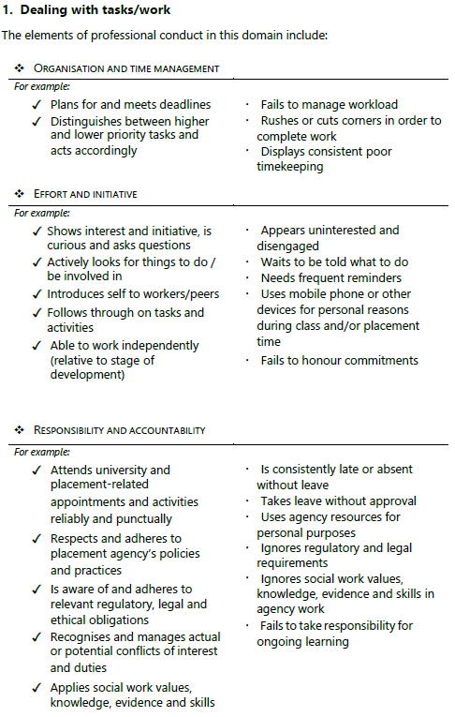

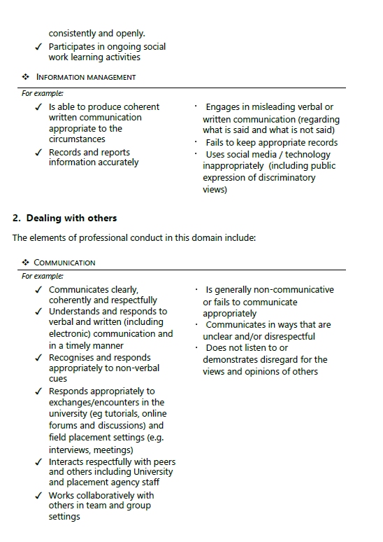

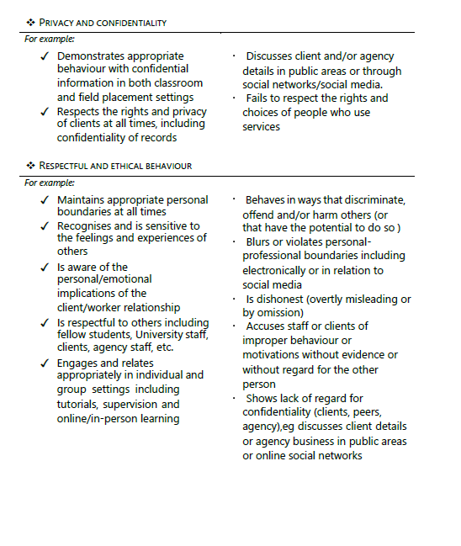

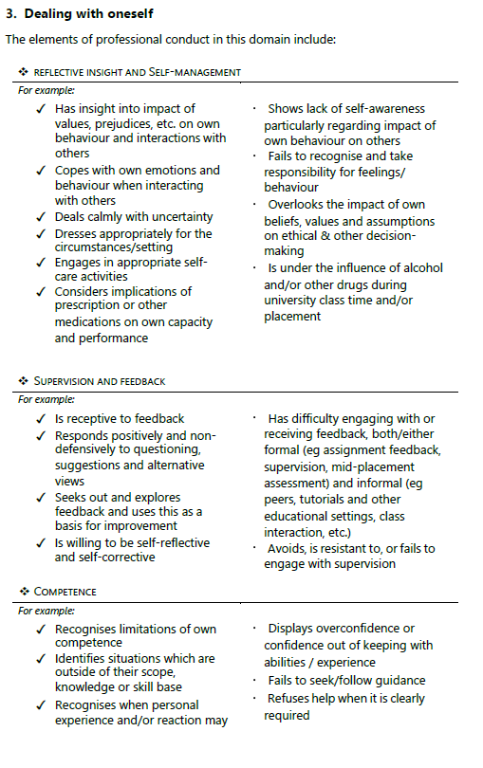

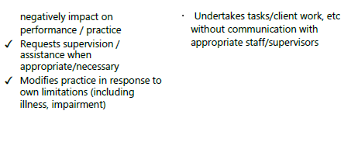

Appendix B - Fitness to Undertake Placement

Tabor has a responsibility to ensure that all students undertaking a work integrated learning placement or activity have the physical and psychological capacity to perform their role and duties within the placement or activity without harming themselves or others. Therefore, it is necessary that Tabor ensures that all students are aware of, and understand, their obligation to report any physical or psychological condition that might impede their ‘fitness to practice’.
The Work Integrated Learning Policy states that all students participating in work integrated learning:
- must have the capacity to safely undertake the inherent requirements of the work integrated learning activities;
- must meet the prerequisites for the subject or work integrated learning activity as defined in the subject outline or handbook for the subject or activity; these may include but are not limited to a Police check and current safeguarding children training for any activity involving contact with vulnerable persons;
- will sign a self-declaration regarding fitness to undertake the placement or activity;
- will act in accordance with Tabor’s Code of Conduct and Student Integrity Policy;
- will act in accordance with Tabor’s Guidelines for Professional Conduct
- will act ethically at all times and respect confidentiality;
- will undertake orientation and induction to the workplace; and
- will comply with workplace health and safety requirements and any other workplace or professional ethical guidelines.

Students enrolled in undergraduate or postgraduate subjects that require them to undertake work integrated learning placement or activity must:
- make a self-declaration regarding their fitness for placement; and
- advise the Head of Program of an existing illness or disability that may affect their ability to practise so that, where possible, a modified placement that will still meet the objectives of the unit can be arranged in consultation with the Academic Director. Where a modified placement cannot be arranged, an alternative pathway will be explored.
The Head of Program or their delegate will notify the placement provider of the strategies to be put in place to:
- facilitate the student’s progress through the placement or activity; and
- safeguard those who are being served by the activity.

Declaration
I, ___________________________________________ have read and understood Tabor’s statement on Fitness to Undertake Placement, and Work Integrated Learning Policy. I declare that I am physically, emotionally and mentally competent to commence and complete my placement. I agree to inform Tabor of any changes of circumstances that should preclude me from starting or remaining in this placement.
I have / have not been refused a placement or WIL activity at another institution. (Please circle the applicable)

Signature: Date:

