Basic Acoustics / Sound engineering
A sound of one pure pitch gives a sine wave:-
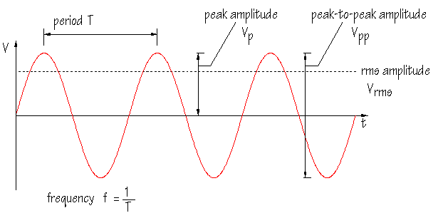
Amplitude = volume
Frequency or pitch = number of cycles or periods per second.
Beats occur when notes are close in pitch but not perfectly in tune. Consider these two sounds that are close in pitch. When added together the volume varies so we hear ‘beats’ from soft to loud repeating. Knowledge of this is useful when tuning instruments together.
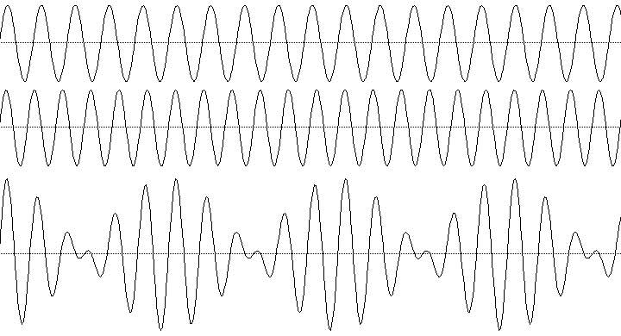

The beats caused by the two pitches represented below will be heard very clearly.
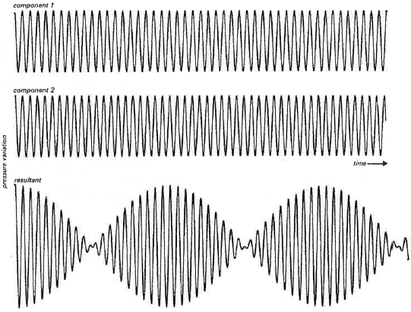

Harmonics
Natural sounds are a combination of pitches. The following give an idea of the complex wave patterns that can result from the addition of pitches (harmonics).
Adding two sine waves of pitches that are accurately within the harmonic series results in:-
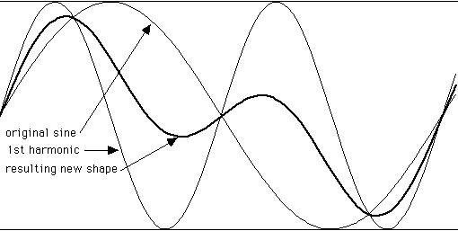
Adding the fundamental pitch and the first 2 harmonics:-

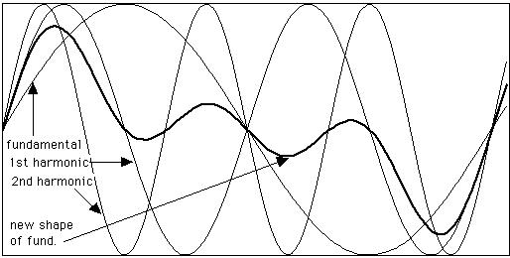
Looking at the above in a different way to show the addition more clearly:-
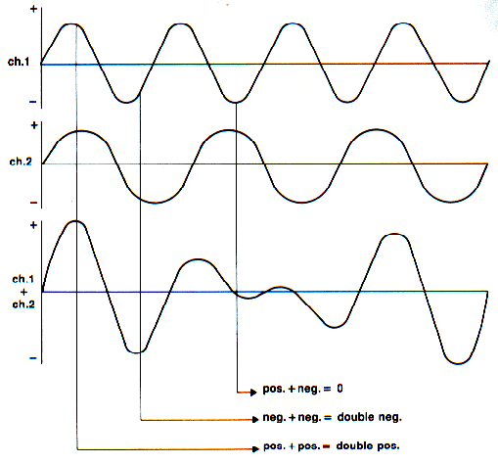

A sawtooth wave is created by adding harmonics in a particular proportion:-
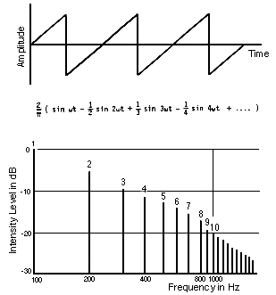

A square wave is made up of the fundamental and odd harmonics in a mathematical relationship. The clarinet produces a sound that is close to a square wave.
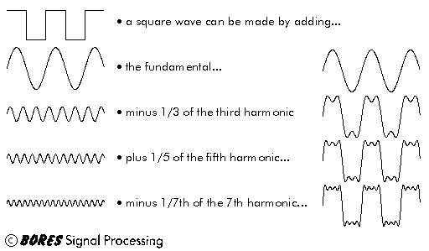

A compression or limiting is a way of automatically controlling volume by reducing the volume when it gets too loud. Most devices can also boost the volume when it gets too soft.

Decay of sounds and their change in tone colour.
Many sounds decay over time in the following manner. Notice that the component sounds decay at different rates.
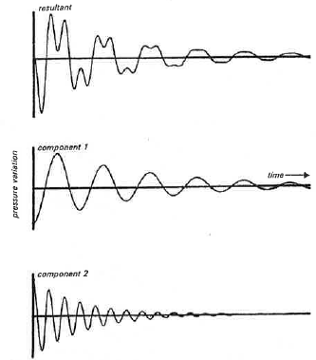

Open and Closed pipes
The left diagram below is a representation of the vibrations inside an ‘Open pipe’ such as all wind and brass instruments except for the Clarinet. The dotted lines refer to the way a string vibrates.
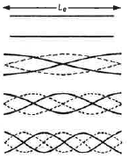
The clarinet behaves like a ‘closed pipe’ at one end, so only fits in half of wave, and the odd harmonics.
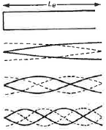

The harmonic content of a few pitches on the Flute, Oboe and Clarinet.
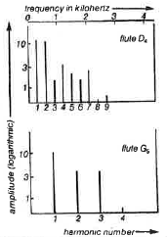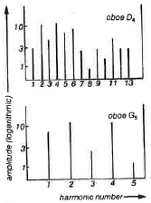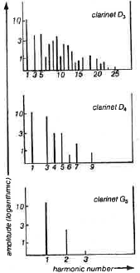
The pitch range of the most common instruments


Human hearing of sound
The equal loudness curves.
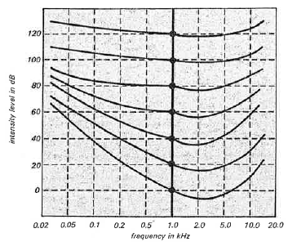
Human ears perceive sounds to be of equal volume across the audible range when at the volumes indicated by the curves. Those sounds in the pitch range of normal speech do not need to be as loud as the very low and high pitches.
There are laws in South Australia related to sound exposure in the work place. These laws limit the time or intensity level that is acceptable without ear protection.
In the music classroom these levels and limits can be exceeded which may lead to permanent hearing loss. For example the intensity of sound from a rock drummer is about 110dB so ear protection should be worn.

The EQ
The EQ (equalisation) is used to either remove (or filter) various pitch ranges or enhance (or boost) particular pitch ranges. Both actions can be very effective in improving the tone colour or clarity of sound. To do this appropriately the operator needs to know the approximate frequency (number of vibrations per second) of various pitches. Refer to the chart of the pitch ranges of various instruments above.

