Music Studies 2025 Possible Answers
These answers are not approved by SACE. They have been put together by Dr Virginia Lakeman as a guide to teachers and students. Accompanying these written answers are Sibelius files of the creative and harmony questions. Where a variety of answers are possible each has been over answered. Students are encouraged to give as many points as there are marks allocated to the question.
- (a) Option 2
(b) Option 4
(c) Option 4
(d) Option 3
(e) Option 1
(f) Option 4
(g) Option 4
(h) Option 3
(i) Option 2
2. 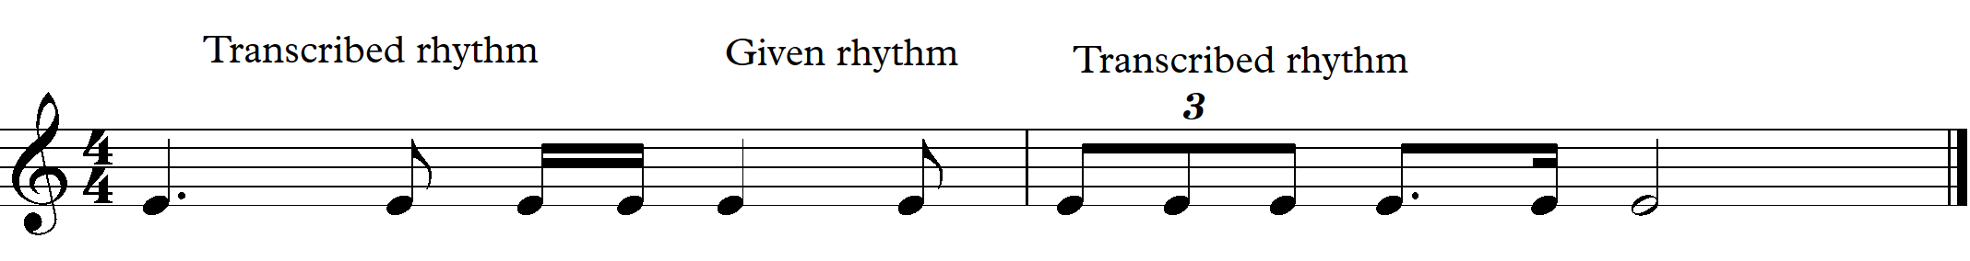
3. (a) Eb7
(b)
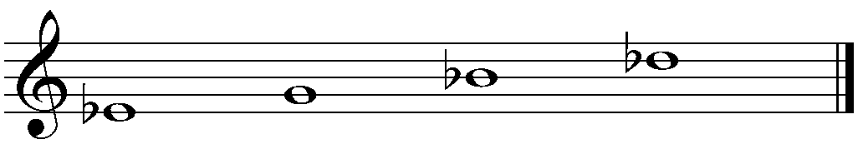

4. (a)
(b)
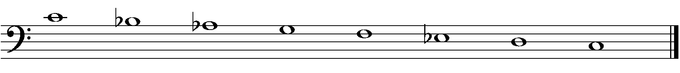
5. (a)
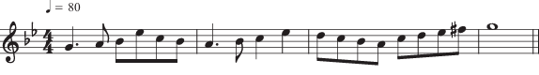

(b)
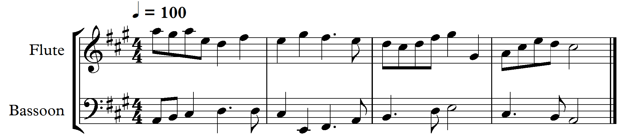
6.
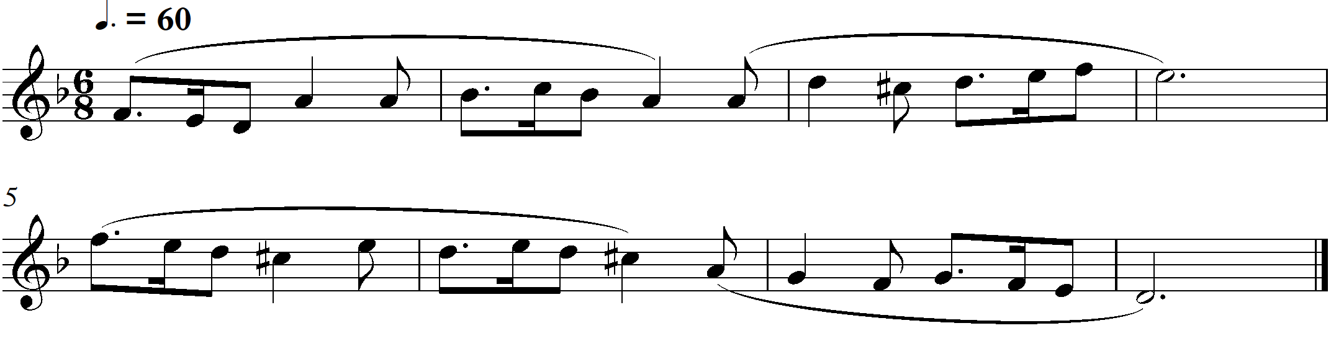

7. (a) Syncopated rhythmic drone of perfect 5th (F# - C#)
(b) Bm/F# OR ivc of F#minor.
(c) (i) arco – with the bow. This follows the pizz (pizzicato – finger plucking) from bar 20
(ii) The three lines through the stem of the note indicate a bowed tremolo -
a rapid series of small movements of the bow up and down.
(d) Tonality- F# natural minor, (F# Aeolian) shifting to B Dorian at bar 10 and returning to F#
Evidence – Key signature of 3#s and no accidentals. Drone shifts from F# C# to B F#.
(e)
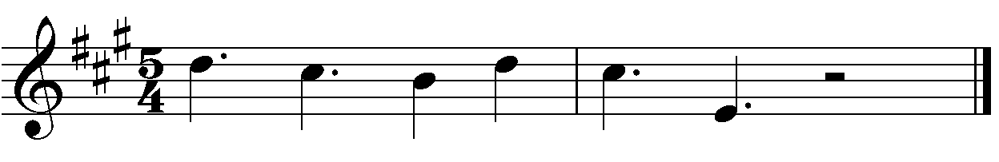(f) Parallel or similar motion - all parts move in the same direction by step or leap but within the
Key signature of 3#s.
(g) Example 1 Monophonic (over the drone) bars 3 – 5
Example 2 Contrapuntal – imitative entries – bars 16 – 17 {OR counterpoint between
Vln I and Vln II – bars 30 – 33.}
Example 3 Homophonic or Choral texture – bars 22 – 23 and 25 – 26.

8. (a) 7
4
(b) (i) Role 1 – Rhythm guitar, playing chords
(ii) Role 2 – playing the riff, initially alone with the bass drum, then as the accompaniment
(c) The riff on guitar begins with the bass drum playing crotchets, the voice is added, then high
repeated note on the keyboard and finally lower right hand keyboard chord repeated.
(d) After the rising scale like introduction the opening section uses a varied major key
progression. The middle section remains on the chord implied by the guitar riff – modal.
The final chorus like section uses a 4 chord repeated harmony.

9. (a) Major 2nd or a tone
(b) (i) Meter – changed from 6/8 compound duple to cut common time simple duple. Beats h h
(ii) Rhythm – Augmentation – the first and third note values have been lengthened to fit the 4/4 meter and there is syncopation - the 3rd note begins on a week beat, the ‘&’ of beat 4.
(c) Alto Saxophone
(d) The tempo marking of 90 remains but at the opening there are 90 minims per minute at 2 minims per bar, and at 23 there are 90 crotchets per minute at 4 crotchets per bar. The pulse remains the same but the length of time for the bars doubles at 23.
(e) (i) Pause – hold the note longer than its value, the length is up to the performer.
(ii) Tenuto – hold the note for its full value
(f) The Soprano Saxophone has the melody which needs to be the focus.
(g) The subdominant

Compare | Chorale | Fughetta
Meter | ¾ simple triple  3 crotchet beats per bar | Cut common  2 minim beats per bar
Tonality | Bb major | A minor
Form | Binary form  Two 8 bar sections with the section from bar 9 in two almost equal phrases  (Hymn like – largely homophonic) | 5 voice fugue exposition bars 1 – 10  Bridge 11 - 12  Episodes bars 13 – 19  Short coda 20 – end  (Contrapuntal)
Timbre | Brass quintet asked to play smoothly.  Bright trumpet tone balanced by the French horn and trombone more mellow tones and grounded by the tuba. | Descant recorder with a fairly shrill but pleasant tone with a more mellow treble recorder tone accompanied by the plucked sounds of the Harpsichord
Use of dynamics | Piano – Soft - or mezzo piano - moderately soft for the opening phrase accompaniment. Mezzo forte for Trumpet 1 – moderately loud – to bring out the melody.  Crescendo for the 4 bars of the second phrase to a forte – loud – for the trumpet 1 melody, supported by mezzo forte – moderately loud - climax beginning in bar 11.  Gradual decrescendo to mezzo piano – moderately soft – to the end.  Dynamic | The harpsichord part has no dynamics given as these cannot be achieved on a harpsichord, unless changing to a new set of strings.  Entries of the recorders are moderately loud, with a decrescendo bars 10 and 11 to moderately soft for the episodes which begin at bar 13  The coda section from bar 20 – moderately loud, with a final crescendo in bar 23 to end forte – loud.
Use of harmony | Mostly triadic harmony with one chord per bar – 2 chords in bars 5 and 14. Some chords to the 7th eg Cm7 bar 6. D7 to Gm - perfect cadence in Gm - across the bar line bar 4 to 5.  F7 ending bar 12 and at the final cadence in Bb, bar 16 to 16  The tuba has the root notes of chords for all change points. | Slightly less complex harmony featuring chords as expected for A minor  Em is found twice in the piano part bar 11 and 18. Mostly E major with the raise 7 features, including at the final perfect cadence .  Tierce de Piccardie ending – A major chord at end – bar 24.

11.
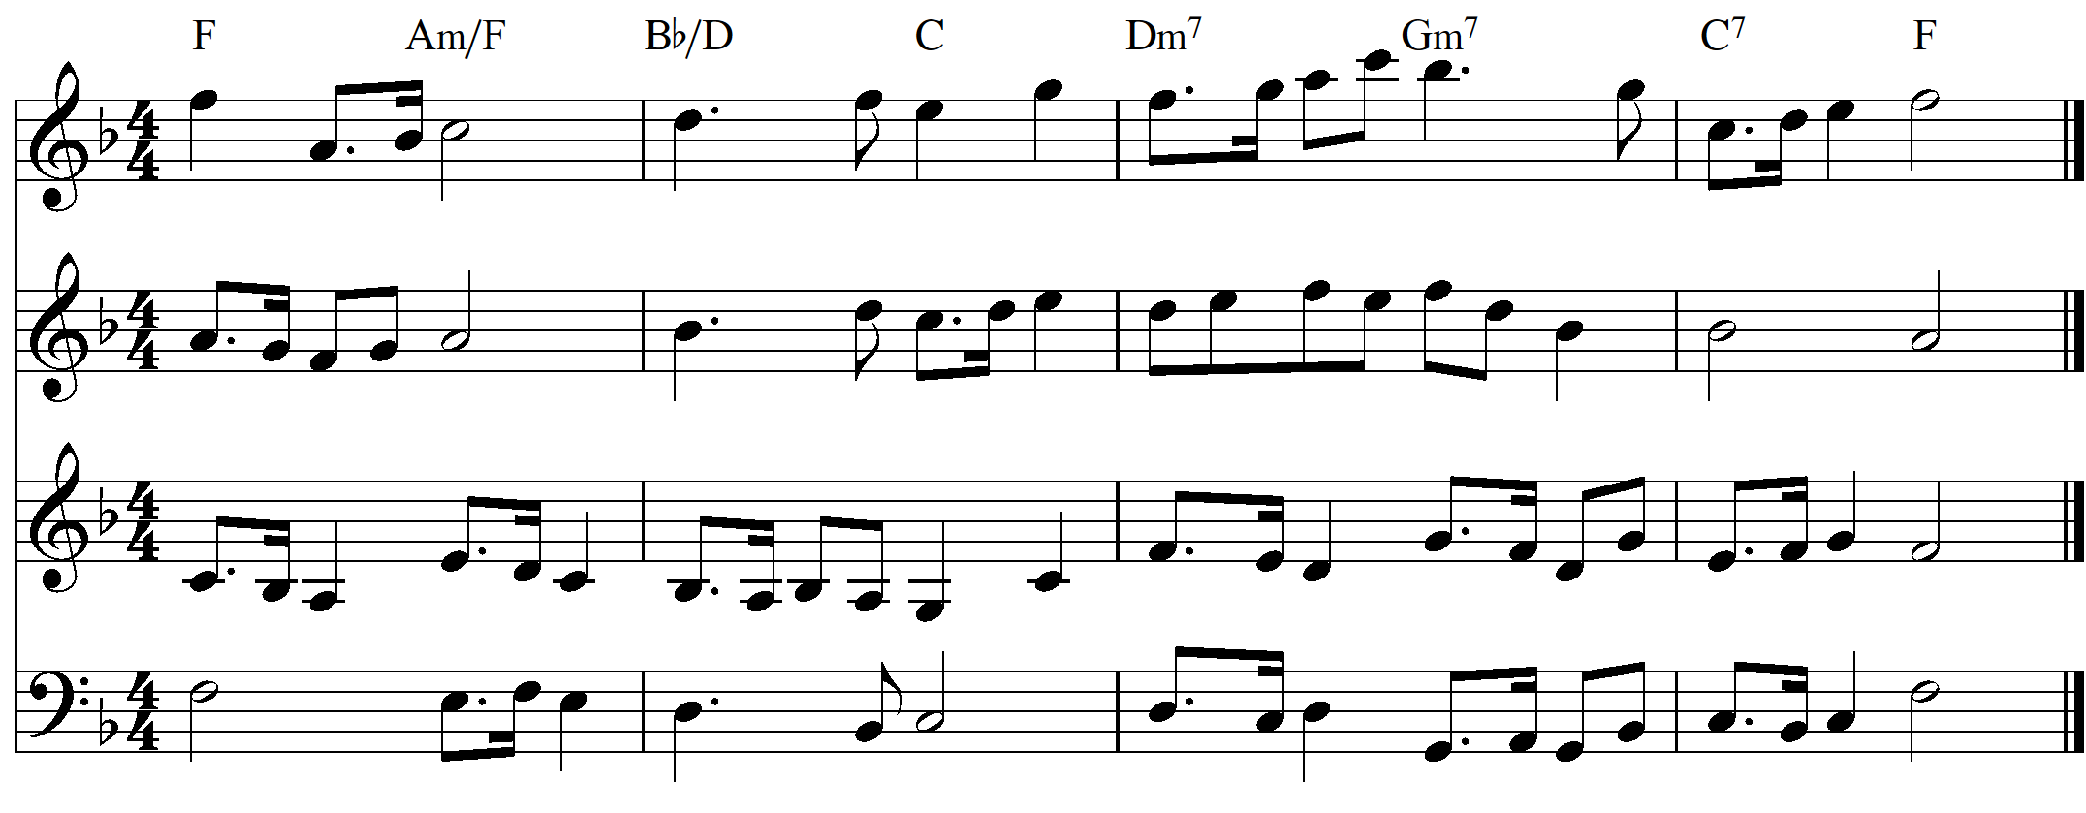
12.
Given Answers
13. Two possible versions are given. Required:- a cadential six-four chord and a dominant seventh.
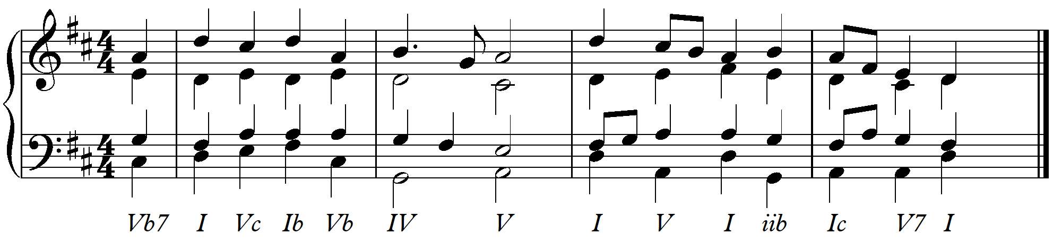
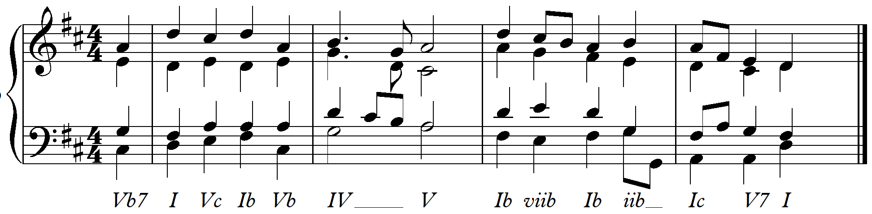
Jazz harmony with two secondary dominants, at least one alteration and at least one extended chord
