Music Studies 2024 Possible Answers
These answers are not approved by SACE. They have been put together by Dr Virginia Lakeman as a guide to teachers and students. Accompanying these written answers are Sibelius files of the creative and harmony questions. Where a variety of answers are possible each has been over answered. Students are encouraged to give as many points as there are marks allocated to the question.
- (a) Option 4
(b) Option 3
(c) Option 1
(d) Option 3
(e) Option 1
(f) Option 1
(g) Option 2
(h) Option 4
(i) Option 1
2. 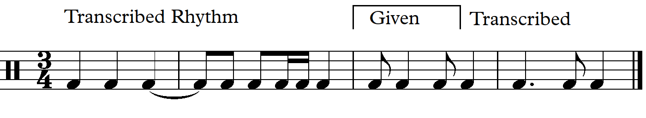
3. (a) Fm7
(b) 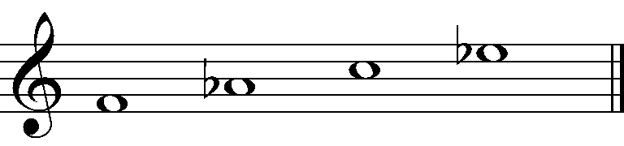

4. (a)
(b)
5. (a)
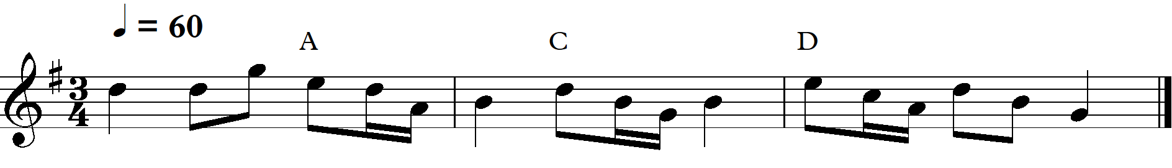
(b) 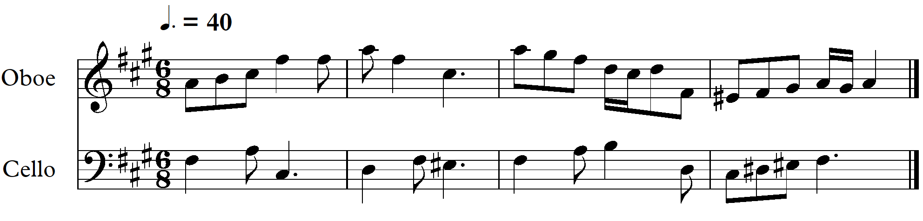

6. (Either) Melody with modulation
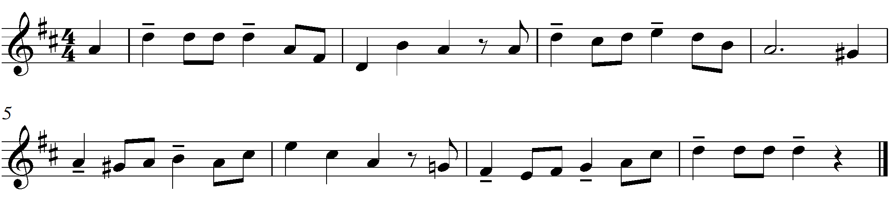

6. (or) Melody without modulation
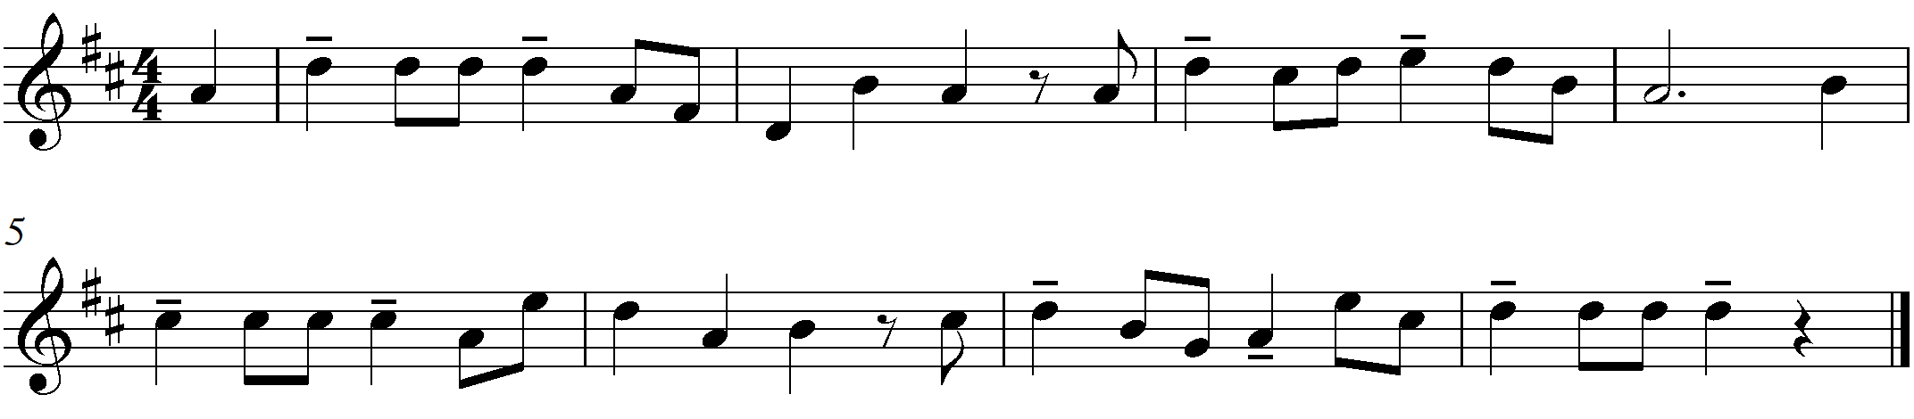

7. (a) Binary form
(b) G7
(c) A half diminished (seventh) AØ
(d) Plagal cadence IV – I in Eb major. (Ab to Eb chords)
(e) (i) The Piano
(ii) 1. The clarinet takes a lesser rol, bars 12 – 25 with rests and a narrow pitch range
2. The clarinet supplies harmony gestures (OR the pitch is lower than the piano melody)
(f) Option 3
(g) The left hand features an Alberti bass. This supplies the harmony and semiquaver
rhythmic drive.
(h) Option 1 – Sequence
(i) Option 3 – Imitation
(j) The opening section A, bars 1 – 8 are in C minor. The B section, bars 9 to the end is in Eb
major, the relative major to C minor.

8. (a) These are used in short contrasting Call and Response (statement, answer) patterns when
present.

(b) Option 4 Multi-layered
(c) (i) Rhythmic effect – syncopation
(ii) Tempo – moderate speed
(iii) Volume – moderately soft
(d) (i) Feature 1 – Turntable scratching type of sound
(ii) Feature 2 – Sleigh bells Or Alternatively – Ring modulator created R2D2 type of
Sound
(e) (i) Pitch – The bell and marimba like sounds have fixed pitched musical sounds other
sounds use the whole spectrum of frequencies/pitches
(ii) Meter – There are some moments of beats and pulse, but these are rare, with the
meter mostly aleatoric or random.
9. (a) Option 2 – A fanfare introduction
(b) (i) Horn in F / French Horn
(ii) Bar 5
(c)
Bar numbers | Broken chord played by the flute
Bar 13 marked (ii) | G major (G)
Bar 14 marked (iii) | A minor second inversion (A/E)
Bar 14 marked (iv) | C major (C)
Bar 14 marked (v) | D major first inversion (D/F#)

(d) Counter melody
(e)
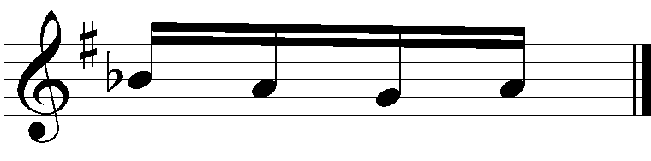
(f) (i)accent on beat 1
(ii) Attack the note a little more forcefully/louder than the previous volume
(g) (i) Tenuto
(ii) Hold for the full value. This does imply a slight accent also.

10.
Compare: | Rhythm/meter | Scale/mode used | Instrument(s) playing the melody
Theme | 4  4 Simple quadruple  Allegro Crotchet=120 | F major | Xylophone and Vibraphone in unison
Variation I | 4  4 with syncopated accompanying rhythm  Lento Crotchet = 80 | D natural minor or  D Aeolian mode | Treble and Bass of the piano in unison
Variation II | 6  8 compound Duple  Presto crotchet = 160  Quaver subdivision of the beats | F Mixolydian | Vibraphone
Variation III | 5  4 a complex time  Medium swing  Crotchet = 60 | F major  (with a chain of dominant chords to end:- D7, G7, C7) | Xylophone in octaves with the treble piano doubling the lower octave

{Coda of 5 bars is not required for discussion – bars 32 – 36}
11.
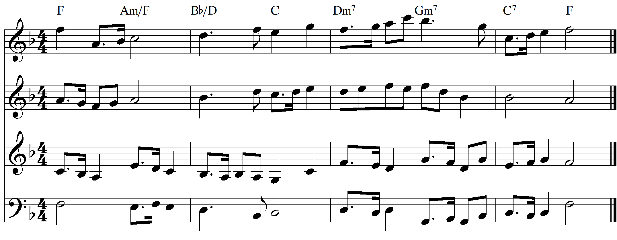

12.
13. Required:- a cadential six-four chord and a dominant seventh, chord inversions and unessential notes in inner parts.
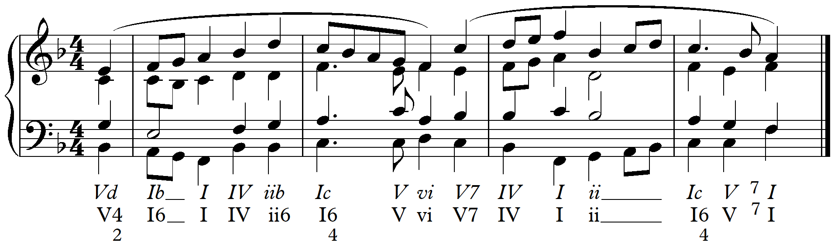

Jazz harmony with two secondary dominants, at least one alteration and at least one extended chord
