The melody for a traditional nursery rhyme, ‘Old King Cole’, will be played once.
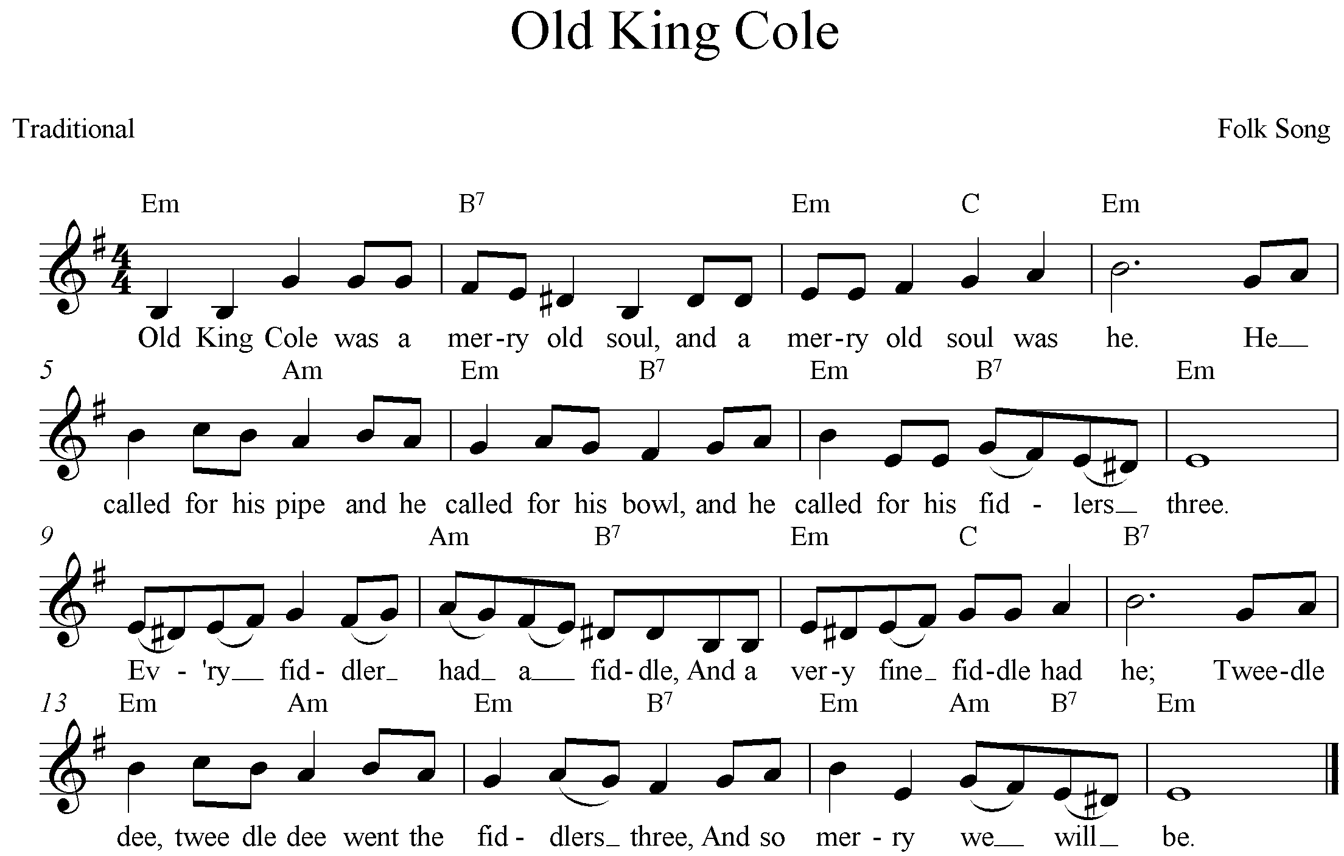
Refer to the arrangement of ‘Old King Cole’ for saxophone quartet on pages ???? of the score booklet.
The ‘Old King Cole’ arrangement will be played twice, with a 60-second pause in between so that you can begin to answer questions (a) to (e) below and on page ???? After the second playing there will be a 7-minute pause for you to complete your answers.
After the 7-minute pause the arrangement will be played a third time so that you can check your answers.
(a) Describe the setting of the first two lines of this folk tune in the opening eight bars (bars 1 – 8) of the arrangement.
The opening is mournful which has been achieved by the slow speed, the sustained chords heard on beats 1 and 3 from the lower three saxophones and the changes in harmony from the original, particularly the use of dissonance and resolution. The first alto saxophone has the tune which follows the original folk melody. The concert pitch key has been changed from E minor to F minor to allow for ease of playing by the saxophones and to make the lowest pitches to be more comfortable to play and to balance within the ensemble. _________________________________________________________________________(3 marks)
(b) How does the arrangement of the following seven bars (bars 9 – 15) contrast with the opening?
The rhythm is swung. It is faster and played at a louder dynamic level. Although the first alto continues with the melody there are now places where the second alto works in rhythmic unison with the melody supplying a harmony. The tenor saxophones continue with their accompanying role, though now the chord changes are not just on beats 1 and 3 as they were in the opening. _________________________________________________________________________(3 marks)
(c) Discuss the rhythmic elements of the third section (bars 17 – 24).
The quavers are now straight rather than swung. The rhythm of the original melody has been altered so that every melody note is of an equal length (quavers) except the final sustained pitch. The original accented melody notes of the folk tune are accented where they fall with the help of supporting staccato chords from the three lower saxophones. This results in changes in metre (time signature) towards the end of this section – 6/8, 3/8 and 2/4.
_________________________________________________________________________(3 marks)
(d) Compare the third section with the final section.
The final section returns to four beats per bar after the changes in metre immediately prior. The fourth section is contrapuntal where each saxophone enters with the opening few notes of the folk tune melody exactly as at the opening. This contrasts with the accompanied melody texture of the previous section(s). The lines are smooth contrasting with the staccato accompaniment and accented notes of section three. The fourth section begins moderately softly and builds to a climax at the entry of the fourth saxophone. This saxophone only has the first three notes of the melody then takes the first of the sustained pitches that feature in the final bars as the dynamic fades. The last chord of the work is a major tonic (tierce de picardie).
________________________________________________________________________(5 marks)

