The melody for a traditional nursery rhyme, ‘Old King Cole’, will be played once.
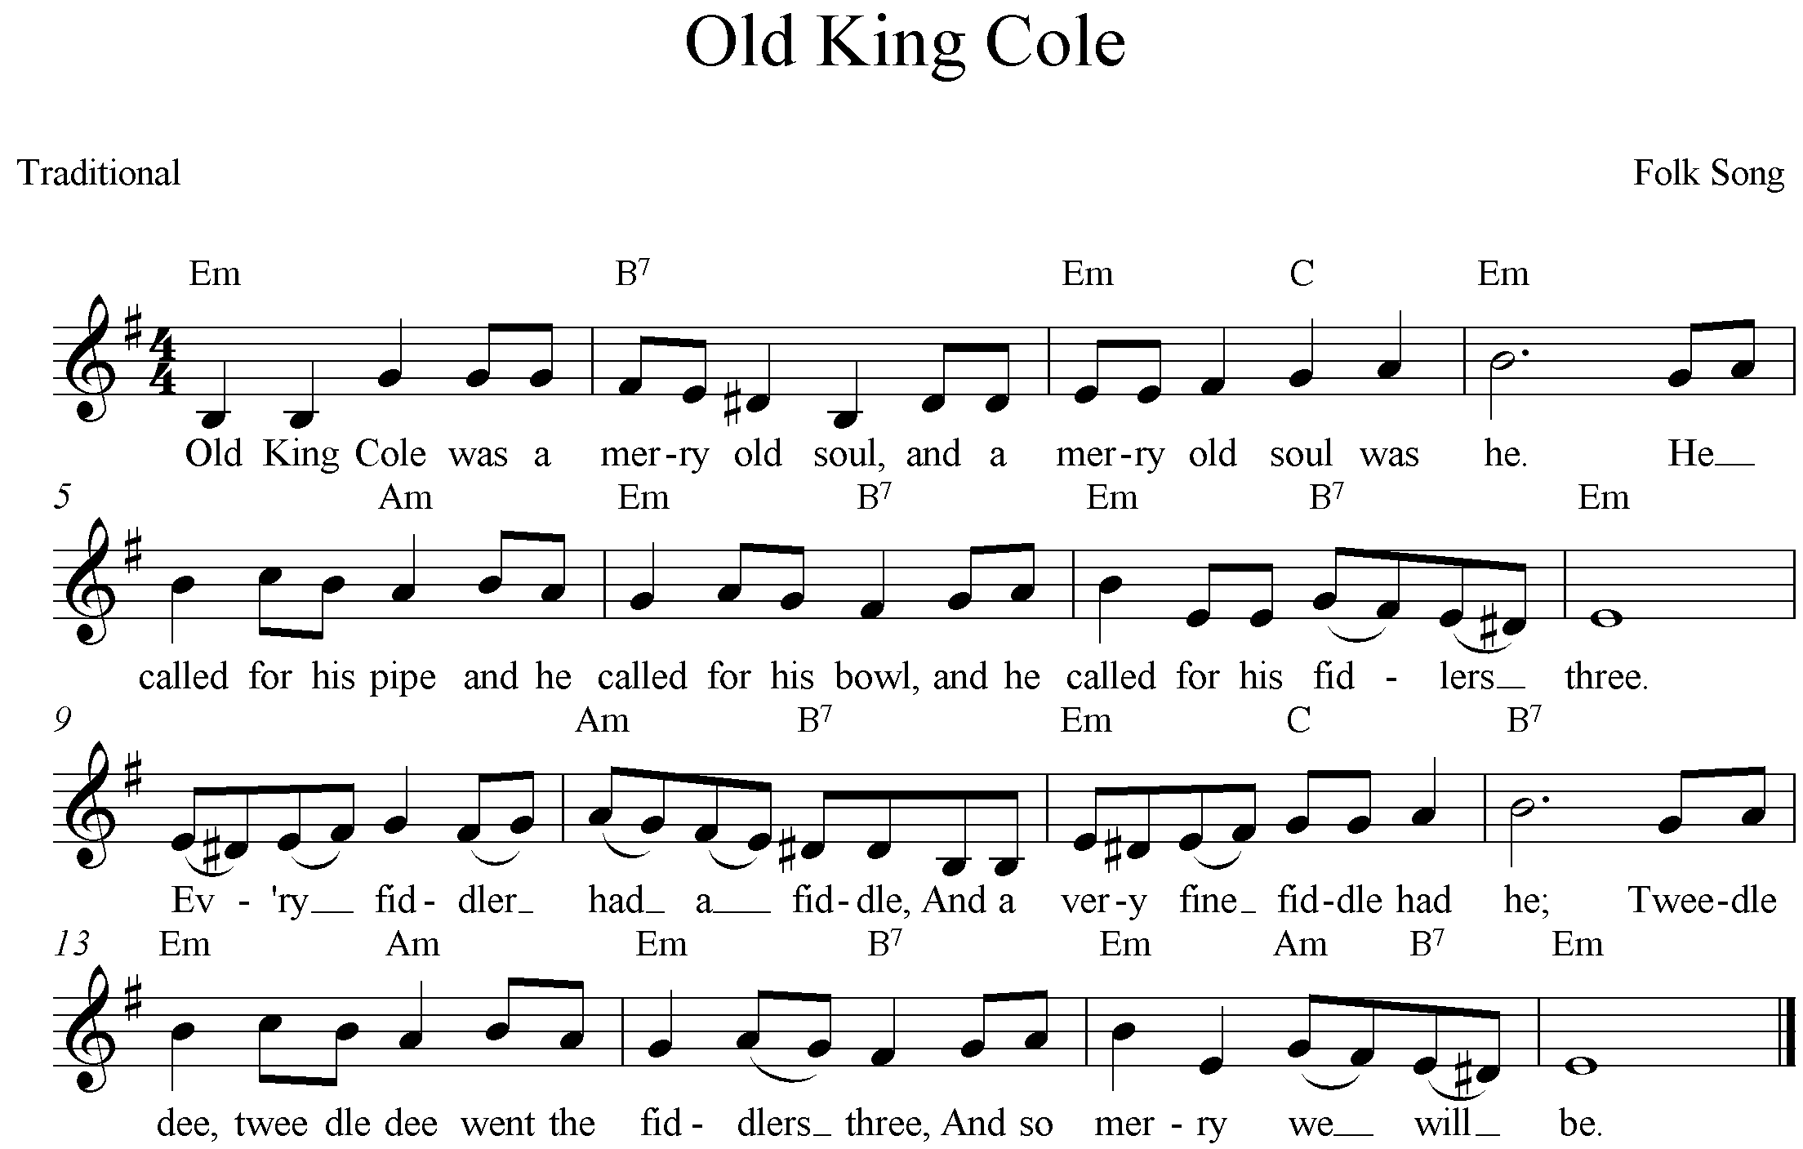
Refer to the arrangement of ‘Old King Cole’ for saxophone quartet on pages ???? of the score booklet.
The ‘Old King Cole’ arrangement will be played twice, with a 60-second pause in between so that you can begin to answer questions (a) to (e) below and on page ???? After the second playing there will be a 7-minute pause for you to complete your answers.
After the 7-minute pause the arrangement will be played a third time so that you can check your answers.
(a) Describe the setting of the first two lines of this folk tune in the opening eight bars (bars 1 – 8) of the arrangement. _________________________________________________________________________________________________________________________________________________________________________________________________________________________________________________________________________________________________________________________________________________________________________________________________________________(3 marks)
(b) How does the arrangement of the following eight bars (bars 9 – 16) contrast with the opening?
_________________________________________________________________________________________________________________________________________________________________________________________________________________________________________________________________________________________________________________________________________________________________________________________________________________(3 marks)
(c) Discuss the rhythmic elements of the third section (bars 17 – 24). ___________________________________________________________________________________________________________________________________________________________________________________________________________________________________________________________________________________________________________________________________________________________________________________________________________________________________________________________________________________________________(3 marks)
(d) Compare the third section with the final section. ______________________________________________________________________________________________________________________________________________________________________________________________________________________________________________________________________________________________________________________________________________________________________________________________________________________________________________________________________________________________________________________________________________________________________________________________________________________________________________________________________(5 marks)

