Traditional four part vocal harmony
Parallel 1st Inversion Sequence

A scale or a scale fragment can be harmonised using entirely 1st Inversion chords in the following manner.

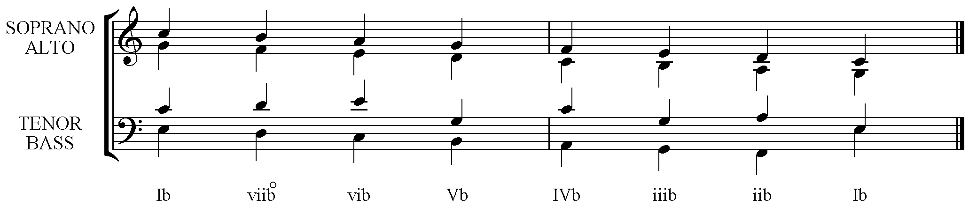

Steps:-
- The Soprano pitches are the Root notes of the chords.
- The Bass notes are the 3rds of the chords and descend or ascend in parallel motion with the Soprano.
- The Alto takes the 5th of each chord, again in parallel motion with the Soprano.
- To complete the harmony, and maintain the 4 part sound, the Tenor part must not make parallel Perfect 5^{ths} or Perfect Octaves with any other part so different notes must be doubled in successive chords. A good pattern, though not entirely used here, is one that alternately doubles the Root then 5th throughout.

Note there are slight weaknesses in the example above in that the Tenor has the same pitch as the Alto on 3 occasions forcing the Alto to pitch a note lower in the next chord. Since the Alto is moving smoothly by step this is a better sounding solution than one that would have these three Tenor notes taken down an octave to make a low 3rd with the Bass in each case.

Scale segments that are higher in pitch than the one given and those that are only 3 or 4 notes long work the best.

