Traditional four part vocal harmony
Passing Notes or Auxillary notes.
Passing notes or Auxiliary notes are unessential notes to the harmony that are not member notes of a harmonising chord. At this stage three diatonic types will be discussed.

Passing Notes
A passing note comes between two chord notes where the pitches in the three-note pattern rise or fall by step in the same direction. There can only be one non-chord note in the sequence. Examine the following and notice that passing notes can be on or off the beat. Accented passing notes are more obvious than non-accented passing notes. They propel the melody onwards with more drive because they create dissonance.
Notes that belong to the harmonising chord are Concordant.
Notes that do note belong to the harmonising chord are Dissonant or create dissonance if they make a 2nd, 4th or 7th with the Root note of the chord.
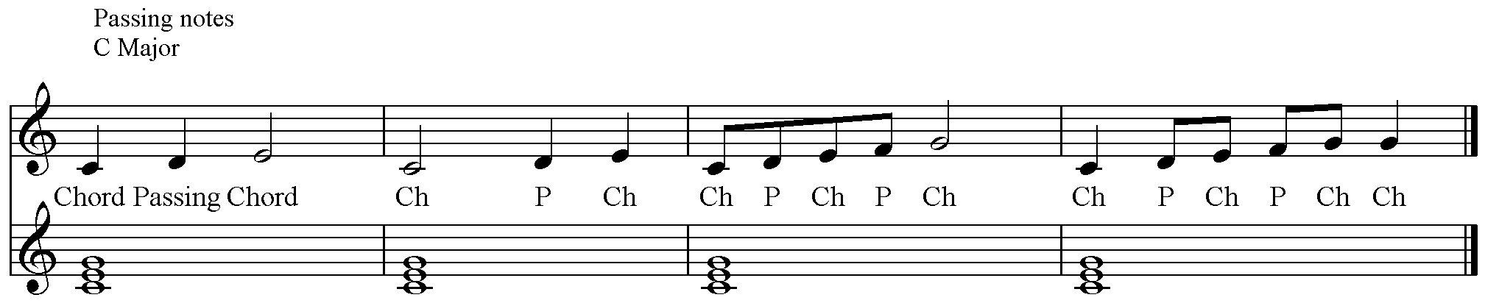
Neighbour Notes
Again it is a three-note pattern this time with the same chord note first and last and a non-chord note between these repeated pitches. The movement is either up or down but always by step. Neighbour notes can be accented or unaccented.
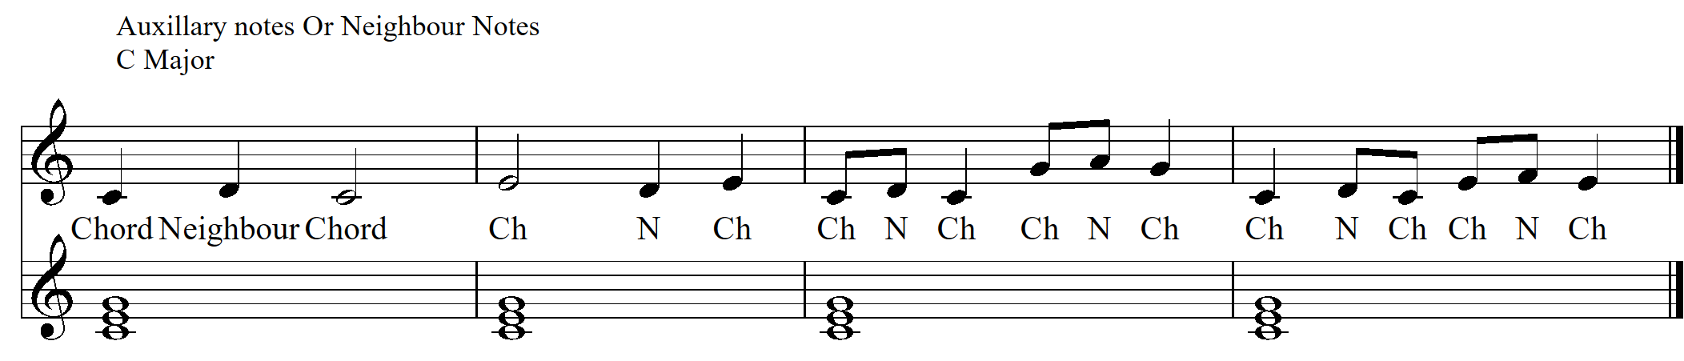

Unessential Notes that leap.
Again it is a three-note sequence. This time there is a leap to the pitch that does not belong to the harmonising chord from a chord note, and a return inside the leap by step to a chord note. These non-chord notes can be accented or unaccented.
