Traditional four part vocal harmony
Cadential 2nd inversion chord sequences
Primary triads only can be used in 2nd Inversion.
There are only two contexts in which a 2nd Inversion can be used successfully, either as the initial dissonant chord in a Cadence, referred to as a
6
4
Cadential.

(OR as a Passing chord. This will be considered later.)
When using a 2nd Inversion chord ALWAYS double the Bass note. (The 5th of the Root position chord.)
The 2nd Inversion chord must be accented when used in Cadences.

Perfect Cadence
Here the 2nd Inversion of the Tonic chord gives the cadence a great deal of forward motion because of the 4th (a dissonant interval) that occurs with the bass note. The 4th is resolved downwards by step. The 4th occurs between the G in the Bass and the C in the Ic chord. Notice that the G has been doubled in the Ic chord.

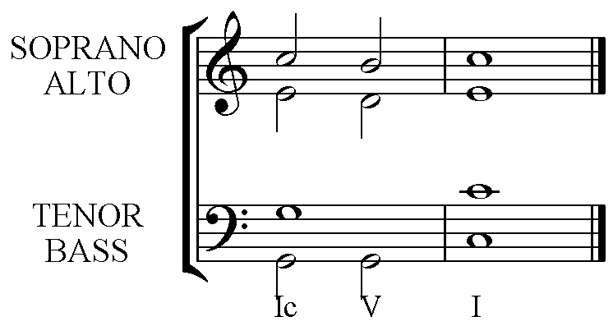

Plagal Cadence
Again the interval of the 4th gives this cadence drive. Here are two possible versions. The first version is the strongest sounding because of the 4th between the Bass and Soprano. The 4th in the second is still active though a little more hidden in the Alto voice by the Soprano. Both are effective Plagal Cadences. Frequently the repeated Tonic is found in the Soprano part.

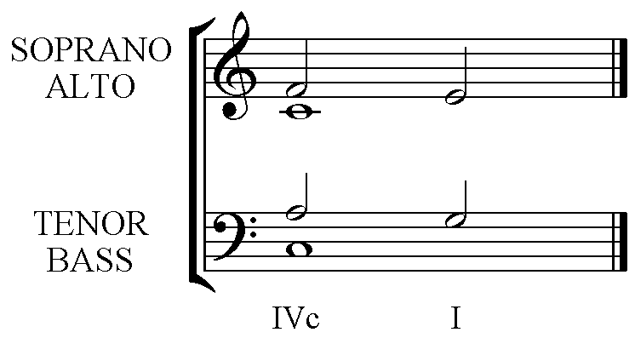 | 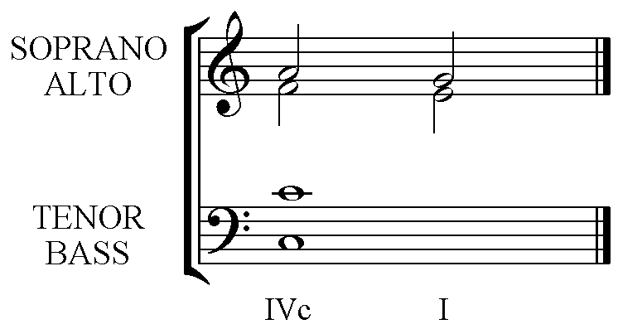

Imperfect Cadence
This is similar to the start of the Perfect Cadence, but is left incomplete without the following chord.
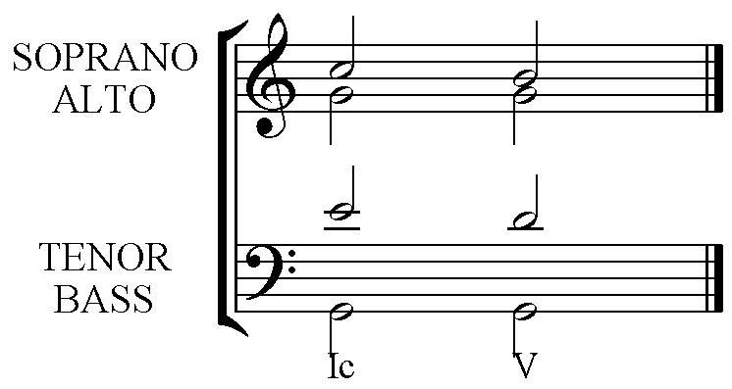

Interrupted Cadence
This cadence begins the same way as both the Imperfect and Perfect and concludes with the Submediant (chord vi).
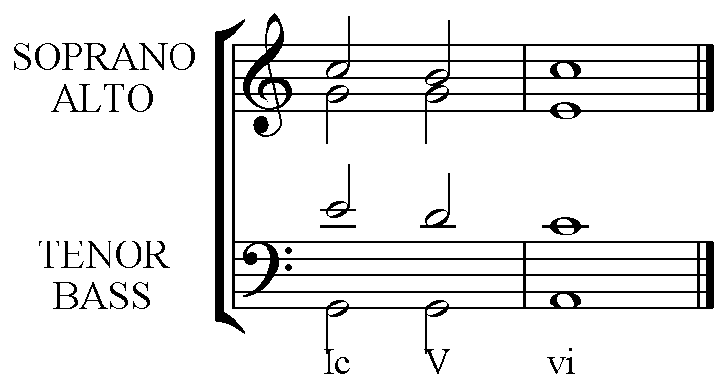

The chord before a 2nd Inversion chord should be chosen with care.

Choose
A chord that has a Bass note a step or 2nd away from the Bass note for the 2nd Inversion chord.
IV – Ic – V – I
IV b – Ic – V – I
iib – Ic – V - I
OR
The Bass leaps from a Root position or 1st Inversion of the same chord as the 2nd Inversion.
Ib – Ic – V – I
I – Ic – V – I

There are other possibilities but those listed above should always be considered first.

