Traditional four part harmony
Passing 2nd Inversions (or 6 chords)
4
Only Primary Triads can be involved in the 3-chord sequence that uses a 2nd Inversion chord as a Passing Chord.
The Bass must move smoothly by step.
All upper parts must move by step with the common note remaining in the same voice throughout as either repeated notes or a long sustained note.
The same chord must be on either side of the 2nd Inversion chord. One will be in Root position, the other in 1st Inversion.
The following are the only possible uses of the 2nd Inversion chord as a Passing Chord. (Obviously these can be transposed to any key and used as written or reversed.)

The Dominant or chord Vc as a Passing 2nd Inversion chord.
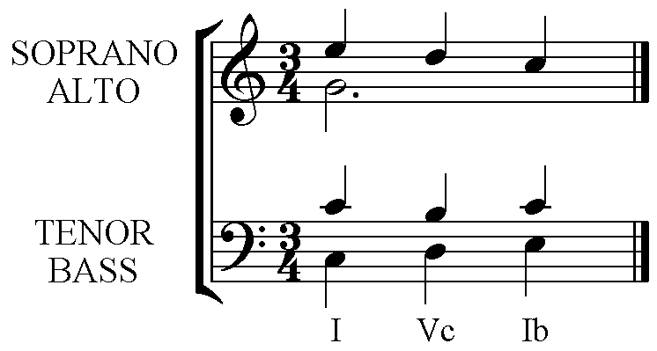 | 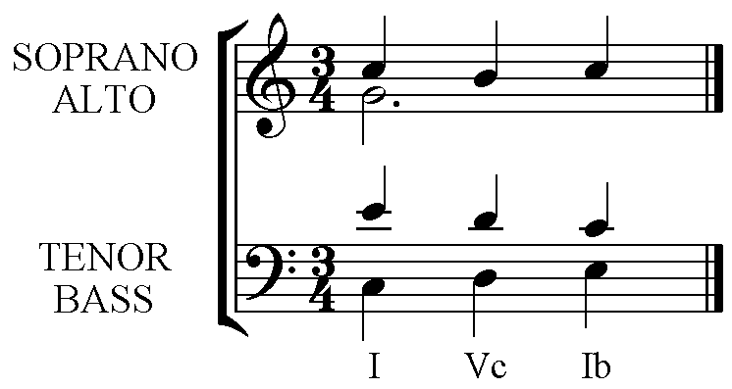
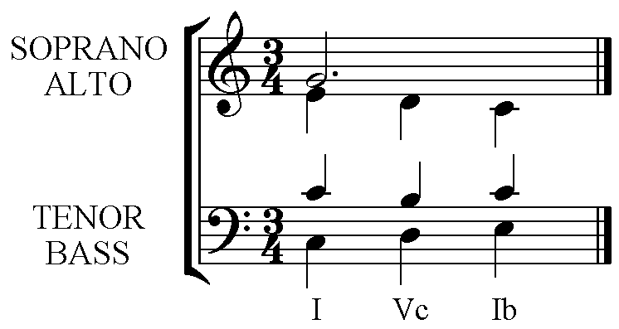

The Tonic or chord Ic as a Passing 2nd Inversion chord.
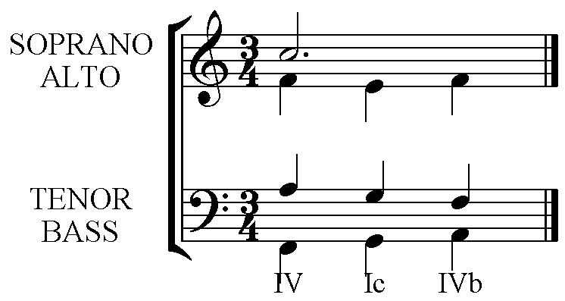 | 