Traditional four part vocal harmony
Repeated notes and Sequences
Dealing with Repeated Notes in the given Melody.
Aim to use a variety of chords under each note to give forward motion.

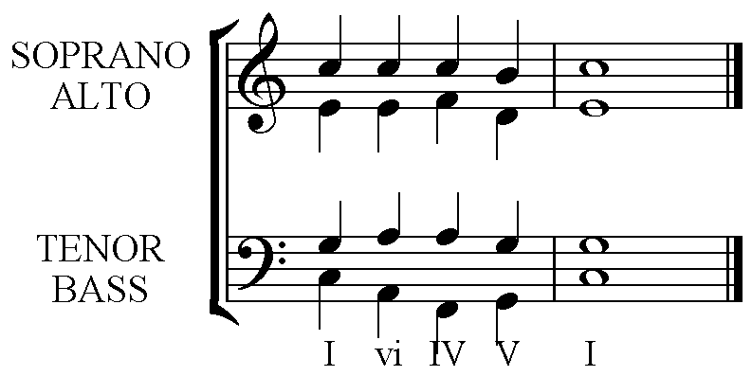

Dealing with a Musical Sequence in the given Melody.
All parts should be a sequence in the completed harmonisation.
The best chord sequences to use are recognised cadences. Eg. Vb – I followed by vib – ii then viib to iii. The initial choice of the 1st inversion was made because the final needed a Diminished chord used properly in 1st inversion.

A simple Sequence using an imperfect (I – V) cadence repeated up a 2nd, becoming ii – vi. The first inversion is used to allow for the fall of the 3rd in the melody. (See Stock Phrases – Melody moves by a 3rd.)

