Traditional four part vocal harmony
The Dominant 7th chord
What are its features?

Built on the Dominant note in a key, it is the only Major triad with a minor 7th in both Major and Harmonic Minor keys.

Triad Type | Root – 3rd | 3rd – 5th | Root – 5th | Root – 7th | Abbreviation | Chord in Key
Dominant 7th | Major 3rd | minor 3rd | Perfect 5th | minor 7th | 7 | 5 or V

It is the only chord that includes the Augmented 4th between notes 4 (Subdominant) and 7 (Leading Note- raised in a minor key).

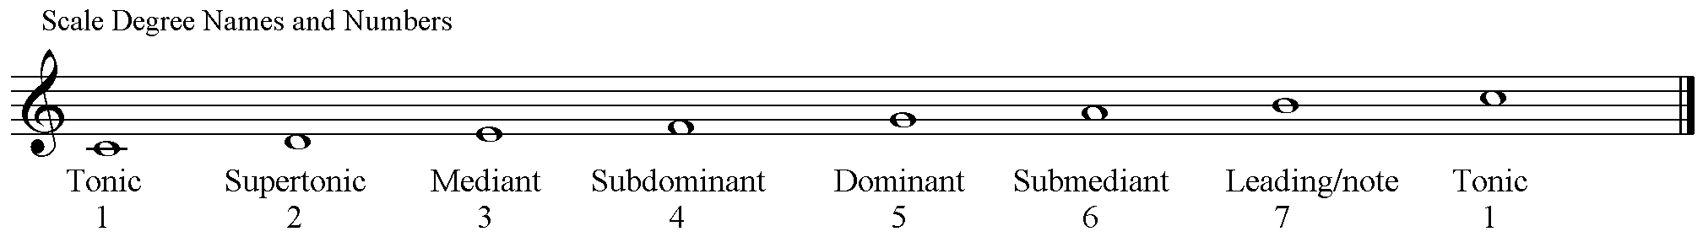

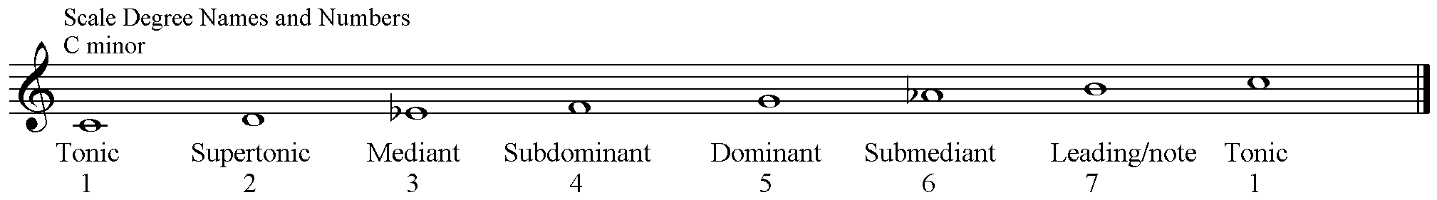

It is this Augmented 4th that makes the chord sound unstable and in need of resolution. This interval is also known as a Tritone (3 tones) it is half of the octave distance of 6 semitones. It is a Diminished 5th when inverted.

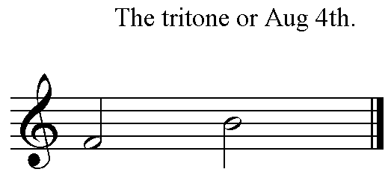 | 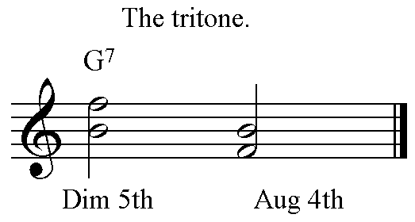

The resolution of the Tritone will always be by semitone steps in contrary motion.

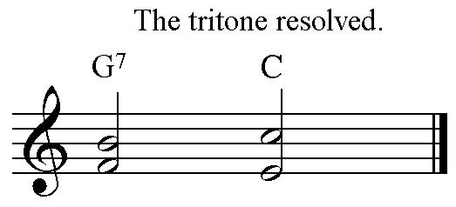 | 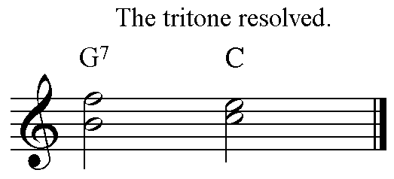

The dominant 7th chord resolves onto a chord that contains the Tonic and 3rd of the key. These notes belong to both the Tonic and the Submediant chords. If the Tonic chord is used a Perfect (5 – 1) cadence is created. If the Submediant follows the Dominant then an Interrupted (5 – 6) cadence is formed.
To imply a Dominant 7th chord only the notes making the Tritone are required. This is useful in two part writing.
Using the Dominant 7th in Traditional Harmony.
This is a 4-note chord so no doubling is required still the 5th could be omitted and the Root note doubled if necessary.
This chord has a ‘powerful engine’ (discussed above), the Tritone between the subdominant and the leading note of the scale, the 3rd and 7th of this chord. The subdominant falls to the mediant and the leading note rises to the tonic.
It is built on the Dominant triad (Major in both Major and minor keys) with an added minor 7th. It is the only chord of its kind in any given key.
It is best not to overuse the Dominant 7th within one harmony exercise. The best places to use the chord are at the beginning to harmonise the anacrusis and in the final Perfect cadence. Both will be completed in this manner:-

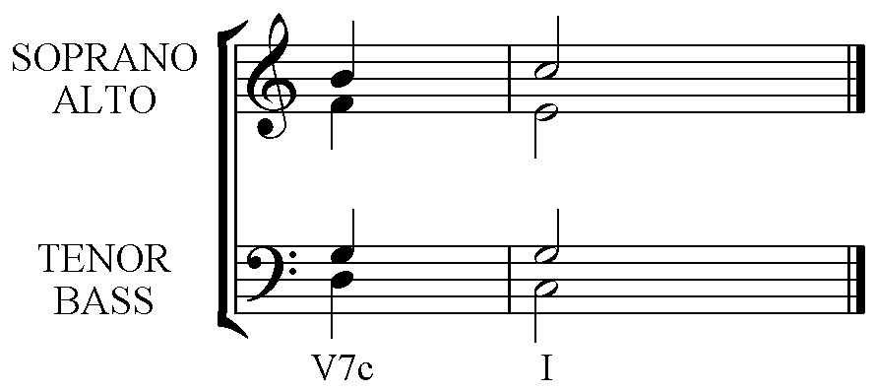 | 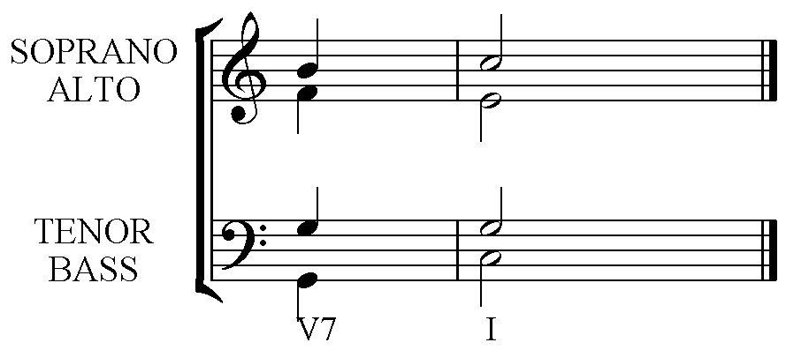

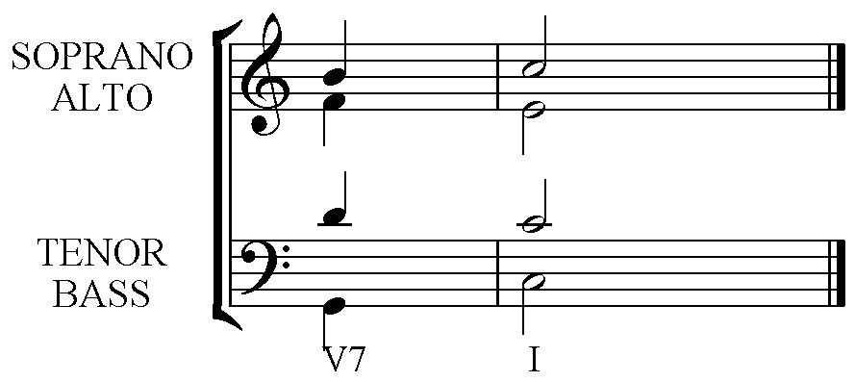 | 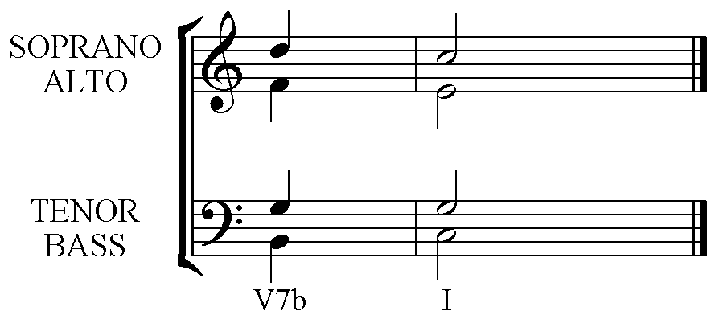
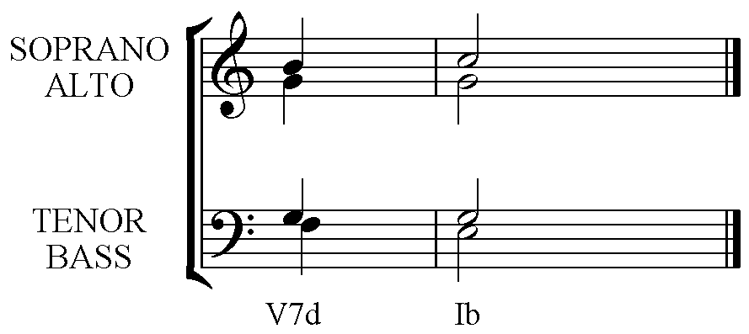 | 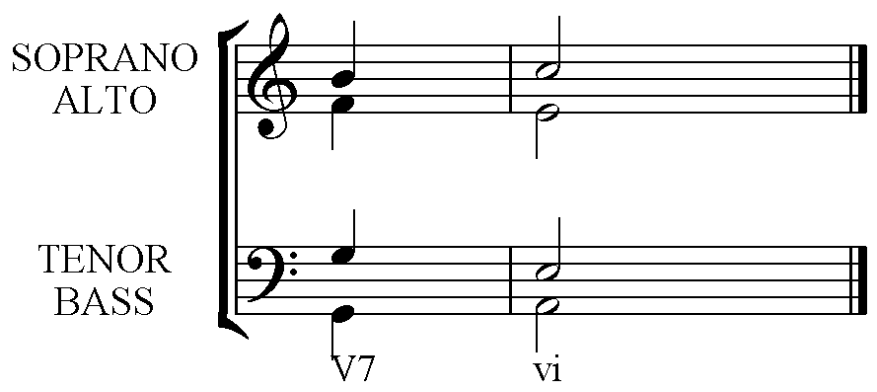

Notice that the Dominant 7th chord can be used freely in any inversion, and that either the Tonic or Submediant chords should follow it.

Scale Degrees – Required voice leading
4 to 3
7 to 1
on every use.

When the Dominant 7th chord uses all 4 pitches then the following tonic may only require the Root tripled and the 3rd. The reverse is sometimes required:- A complete Tonic chord (with root, 3rd & 5th) may need an incomplete Dominant 7th chord preceding it. The 5th of the Dominant 7th is the one to omit.
SO:-
Incomplete Dominant 7th (omit the 5th) resolves to a Complete Tonic
Complete Dominant 7th resolves to an Incomplete Tonic (Omit the 5th)

