Traditional Four Part Vocal Harmony

First inversion chords and notes to double

The following chords are written in close position and in 1st Inversion indicated by the ‘b’. First inversion chords can also be indicated by the number ‘6’ as the interval from the lowest pitch to the highest is a 6th. The 3rd above the lowest note is implied by the ‘6’.
Each chord is indicated by the scale degree numbers in Roman numerals - upper case for major chords and lower case for all others. The circle is used for diminished and the + for augmented chords.

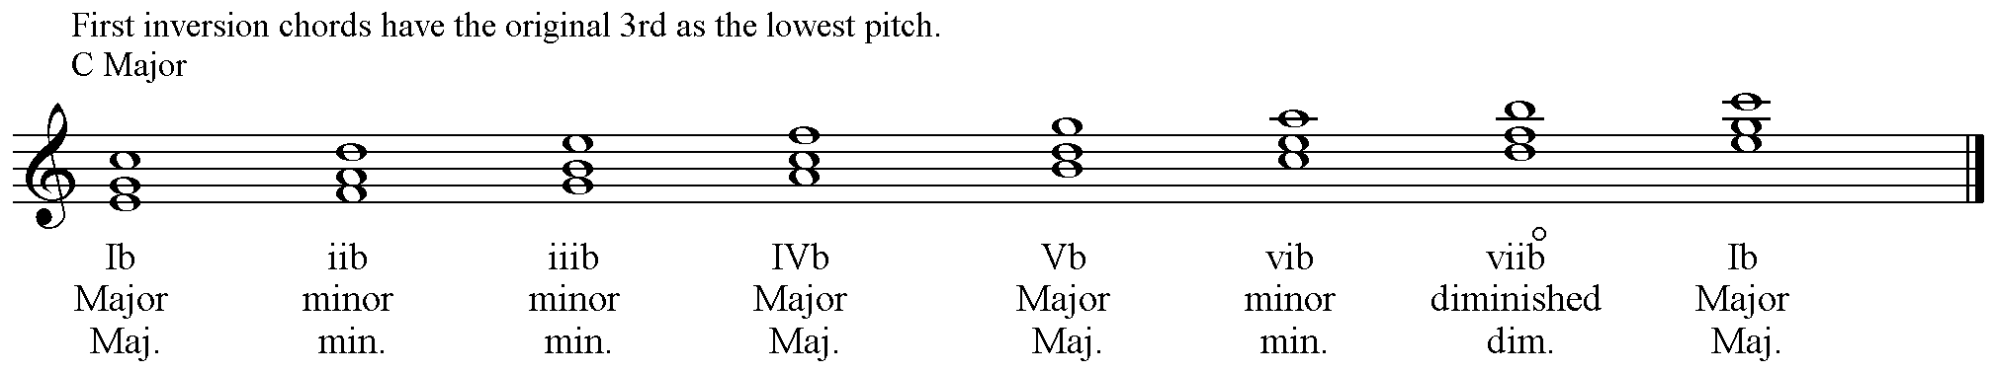

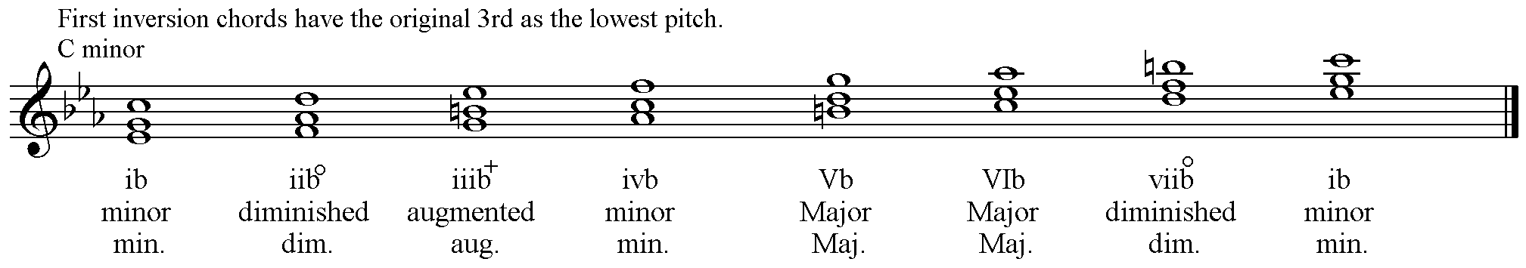

What Inversion to use and what note to double?

Chords are generally used in either root position or first inversion. Second inversion chords can only be used under certain conditions. These will be discussed later.

For four part vocal harmony four notes are required. This means that one note must be doubled in each chord.

The choice of inversion and the note to double is determined by the type of chord.

Diminished triads should only be used in First Inversion with the original 3rd of the Root position chord – now the lowest pitch – doubled.

Augmented triads should not be used.

Major triads can be used in Root position and 1st Inversion freely. Either the original Root or 5th may be doubled in Root position chords. For 1st Inversion chords the same pitches may be doubled.
NEVER double the 3rd of a Major triad except the 3rd in chord VI, which is the Tonic of the key and may be doubled.
NEVER double the leading note of the key.

