Traditional Four Part Vocal Harmony

Vocal Ranges and Chord Voicing

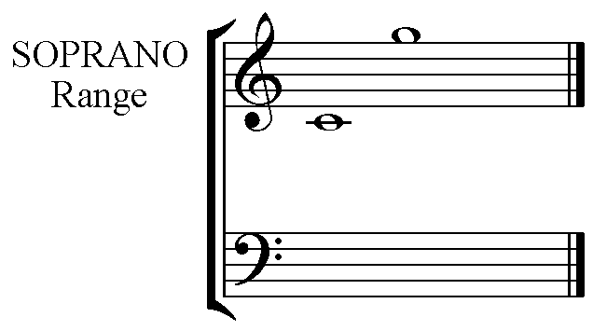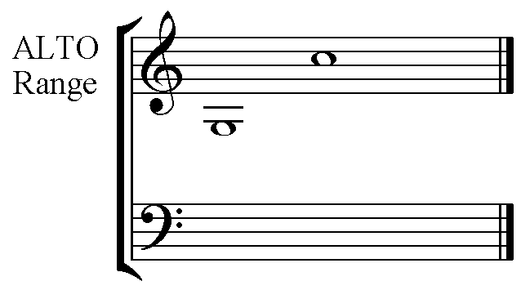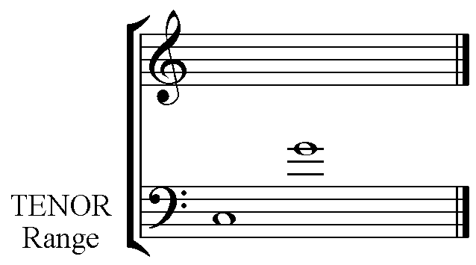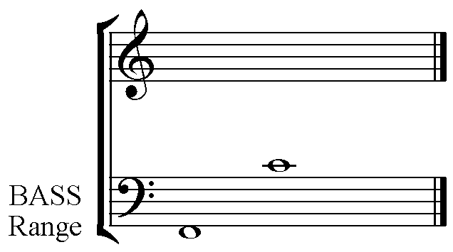

The ranges given here are approximate for particular voice types, however for choral writing they are considered absolute.

Soprano C to G Alto G to C
Tenor C to G Bass F to C

Note the similarity of pitches between the high female and male voices - Soprano and Tenor - and the low female and male voices - Alto and Bass. Notice that the Bass voice is considered to be able to produce one pitch lower than the ‘pattern G to C’.

Chord Voicing

There are many ways to voice a chord. The pitches of the triad do not need to be assigned in close position nor in pitch order.
Generally the largest interval is found between the Bass and Tenor pitches.
High Soprano pitches need support from the other parts with notes that are high in either /or both the Alto & Tenor ranges.
Do not exceed an octave between Tenor and Alto, OR Alto and Soprano. Keeping the Tenor part high in the range will usually be most effective.

Note the stem directions for each part when writing 4 part Vocal Harmony on two staves:-

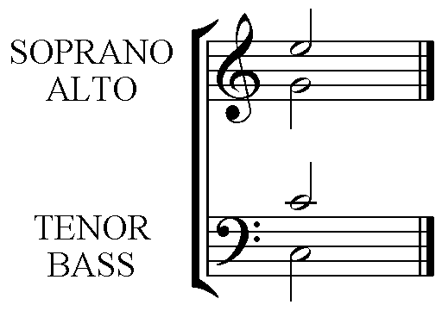

Stems up for Soprano and Tenor, and Stems down for Alto and Bass.

