Traditional Four Part Vocal Harmony

Smooth Voice Leading and Perfect Cadences
Smooth Voice Leading
When writing successive chords in 4 Part Vocal style always aim to move each of Soprano, Alto and Tenor part smoothly to the note in the next chord. The Bass part will leap if chords in Root position are generally used. The only exception to this comes when successive 1st Inversion chords are used. Parallel 1st Inversion Sequences will be discussed later. Always avoid awkward leaps, crossing and overlapping parts.

Cadences
Cadences are musical punctuation.
There are two Cadence types that act as Full Stops in music. The Perfect Cadence (Generally V to I) and the Plagal Cadence (IV to I) or Amen.
The second type of Cadence acts as Musical commas:- Imperfect and Interrupted. These will be explained fully below.
The following is a Perfect Cadence in C Major. Note that the Soprano has the common note to each chord, the Alto and Tenor move smoothly by step and the Bass leaps to the root note of the new chord. The accent pattern is always weak to strong.

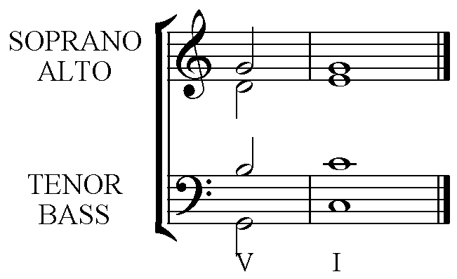
5 1 The top three can be in any upper part. The lines
2 5 indicate smooth voice leading. Note that the
7 3 Leading note rises to the Tonic.

5 1 The Bass has the root notes of the chords in Cadences.
Chords V I

The alternative Voice leading for a Perfect Cadence, used only when the melody notes are:- 2 to 1.

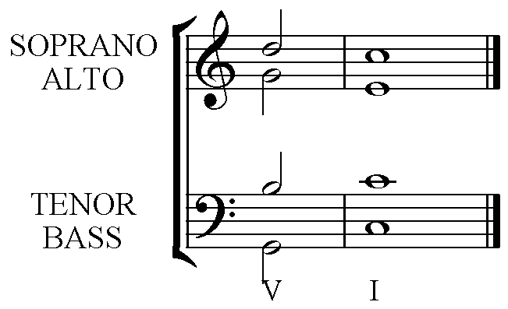
Notice that the Tonic has been used three times and that there is a leap from note 5 in the Alto in chord V to the third of the Tonic chord. The 3rd of the chord is required to define the chord as Major or minor, and must not be omitted.
5 1 The top three can be in any upper part. The lines
2 3 indicate smooth voice leading. Note that the
7 1 Leading note rises to the Tonic and the 5th has been
omitted in the Tonic chord.
5 1 The Bass has the root notes of the chords in Cadences.
Chords V I

