Traditional Four Part Vocal Harmony

Plagal, Imperfect and Interrupted Cadences
The Plagal Cadence
Frequently used as the ‘Amen’ after a Perfect Cadence. The chords in this cadence should also be accented weak to strong.
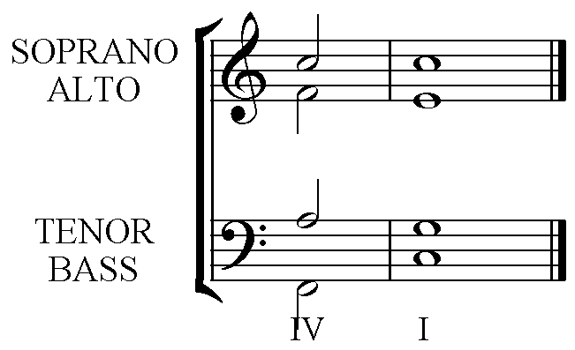
4 1 The top three can be in any upper part. The lines
1 5 indicate smooth voice leading.
6 3

4 1 The Bass has the root notes of the chords in Cadences.
Chords IV I

Imperfect Cadences

These are intermediate phrase endings that always sound unfinished.
There are several chord combinations that give this effect. In each, chord V is the second/final chord. Note the dashed bar line, indicating that the cadence chords can either be weak to strong, or strong to weak.

I – V
This cadence should follow the pattern of a Perfect Cadence in reverse.
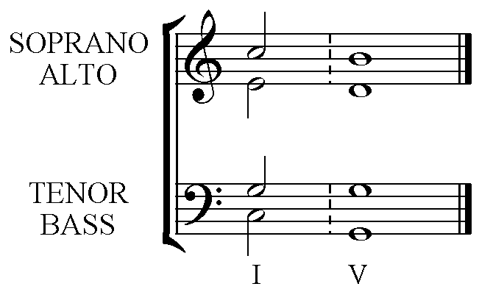

ii – V
This cadence should follow the pattern of a Perfect Cadence in the Dominant key but without making chord ii into a major chord by raising the F to F#.
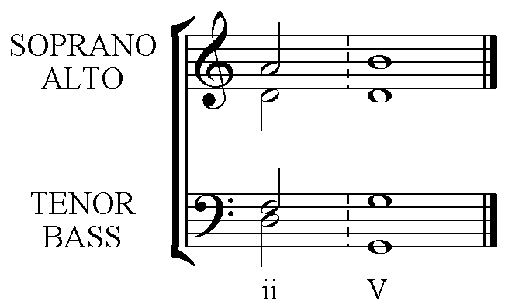

IV – V
The chords in this cadence have their root notes side by side in the scale. This presents some problems, in particular the possible parallel 5^{ths} or octaves. The problems can be avoided by completing the cadence with:-
All upper parts moving in contrary motion to the Bass.

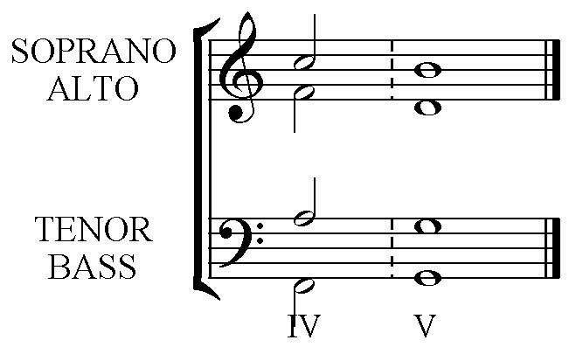
The Soprano, Alto and Tenor lines descend, this is in contrary motion to the ascending Bass pitches.
vi – V
The chords in this cadence also have their root notes side by side in the scale, presenting the same problem of possible parallel 5^{ths} or octaves, AND in the case of the cadence in the minor key:- the possibility of an Augmented 2nd between the two notes in one of the upper voices. The problems can be avoided in both Major and minor keys with:-
Double the 3rd in chord vi (the Tonic of the key) and move from the doubled 3rd by step in contrary motion.

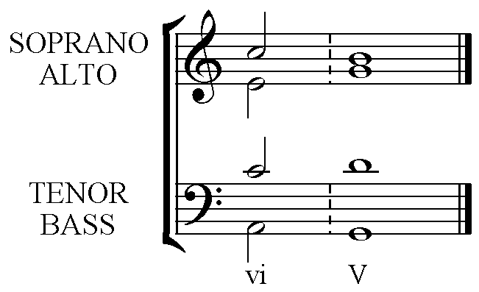
C, the 3rd in chord vi, is doubled with the Soprano C moving down to B and the Tenor C moving up to D for chord V.

The Interrupted Cadence

V – vi
This cadence is completed in the same manner as the vi – V but in reverse. It sounds almost as though the cadence will be a Perfect Cadence as it begins on chord V (the Dominant). The listener is expecting the Tonic or chord I to follow, but hears chord vi the Tonic of the Relative minor scale. This sounds unfinished.
Double the 3rd in chord vi (the Tonic of the key) and move to the doubled 3rd by step in contrary motion.

