Traditional Four Part Vocal Harmony

Parallel 5^{ths} and Octaves – Why the fuss?

Acoustics

Every musical sound is a mixture, in a particular pattern, of musical pitches. For almost all instruments the pattern is the same, however the relative loudness of each pitch is different allowing us to recognise the particular sounds of each instrument.
This pattern is:-

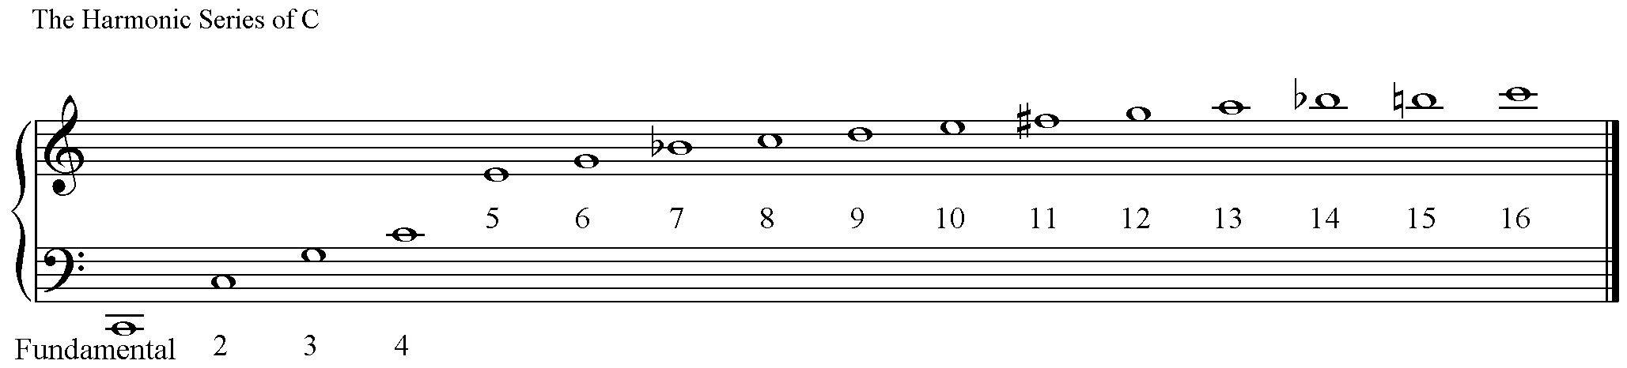

Notice:-

- The largest interval between successive pitches is a Perfect Octave between the fundamental and 2nd note in the series, (often called the 1st harmonic.)
- The interval between the 2nd and 3rd pitches is a Perfect 5th.
- That pitches 1, 2, 4, 8, & 16 are the note C. (In vibrations per second, measured in Hertz 1 = 64, 2 = 128, 4 = 256, 8 = 512, 16 = 1024.)
- Double the number of the harmonic or the number of vibrations per second and you have a pitch one Octave higher.
- The Bb’s, F# and B natural are all out of tune in our ‘equal temperament’ tuning system. (String players bow a 7th of the distance of the string away from the bridge to cancel this out of tune Bb, leaving a purer and more melodious sound/timbre.
- More harmonics are produced on some instruments. The next octave moves upwards by steps of approximate semitones.
- The higher harmonics are closer together in pitch.
- The relative volumes of each of these pitches creates the ‘timbre’ or instrumental/vocal tone colour.

Equal Temperament was first used in J.S. Bach’s day. It is a compromise system of tuning. It divides the octave into equal semitones, which the Harmonic Series does not. For the first time it was possible to play fixed pitched instruments, such as keyboard instruments, in all keys. Bach demonstrated this with his two sets of 24 Preludes and Fugues – one in each of the 12 Major and 12 minor keys.

What does this mean?

Perfect 5^{ths} and Perfect Octaves. To our ears these intervals, when sounded together, blend so ‘perfectly’ that the resulting sound seems like one single pitch with a slightly different timbre.

When two voices move in parallel Perfect 5^{ths} or Perfect Octaves the two voices for that moment sound like one voice. This reduces the harmony from a 4 Part sound to a 3 Part sound, reducing the texture to something that sounds just a bit empty.

Chord Voicing
The large intervals in the Harmonic Series are at the bottom. When voicing chords the largest interval between pitches should be at the bottom between the Bass and Tenor voices. It can be more than an octave.

Note that there is no 3rd of the C Major triad in the first octave of the Harmonic Series. Low 3rds sound very muddy and gruff to our ears. Avoid low 3^{rds} in your harmony. In general avoid 3^{rds} between Bass and Tenor if the Bass has a note lower than the G in the 4th space.

Pitches in the Harmonic Series become closer together the further up the series. In Chord Voicing the higher the pitch the closer the supporting pitches should seem either in the Alto or the Tenor part. A high tenor pitch can support a high soprano pitch just as effectively as an Alto part a 3rd lower than the Soprano even though the Tenor pitch is in a register an octave lower than the Soprano register.

