Traditional Four Part Vocal Harmony
Steps in Completing Cadences.

- Name the key and type of cadence and check the correct method for completing that particular cadence.

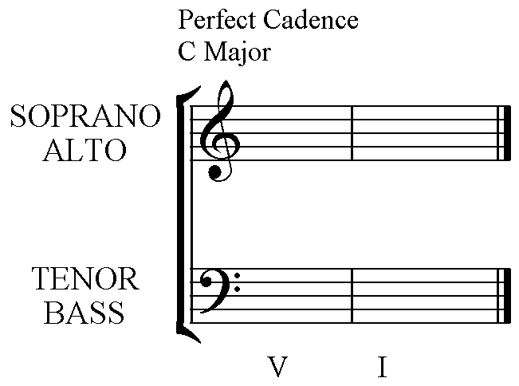

5 1 The top three can be in any upper part. The lines
2 5 indicate smooth voice leading. Note that the
7 3 Leading note rises to the Tonic.

5 1 The Bass has the root notes of the chords in Cadences.
Chords V I

- Write the letter names of the notes in each chord to be used.

G C
D G
B E

G C
Chords V I

- Put the root notes of each chord in the Bass part. These notes will be the lowest pitches in your completed cadence.

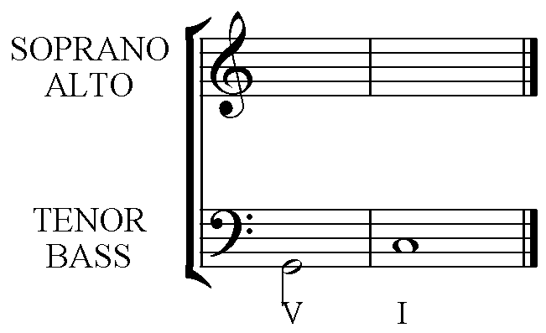

- Voice one of the chords completely. (It does not matter which one you choose.) Keep the largest interval between the Bass and Tenor, and keep the Tenor fairly high. The Alto and Soprano should be fairly close with both pitches higher than the Tenor note.

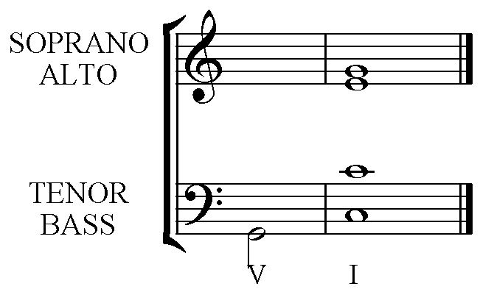

- Find the pitch that is common to each chord and put that pitch in the same voice in your second chord.

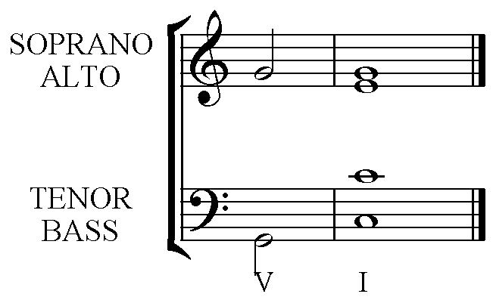

- Work out the best way to make each of the remaining two voices move smoothly by step then put these notes on the stave in your second chord.
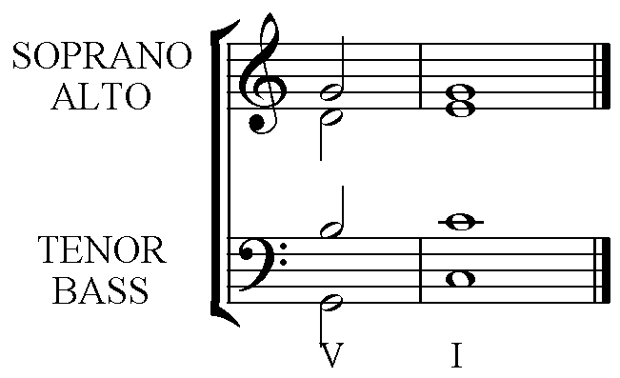
- Check that each chord is spelt correctly. Especially check that you have raised the Leading note in Chord V of a minor key.

- Check that the order of pitches in each chord from lowest to highest is:- Bass, Tenor, Alto, Soprano. This avoids the error ‘Overlapping parts’.

- Check that you haven’t taken one voice below or above the pitch that another voice has just sung from the first chord to the next. This avoids the error of ‘Crossing Parts’. Pitching a note that is lower or higher than your neighbour has just sung is quite difficult to do accurately.

- If you have followed the pattern you should not need to check for Parallel Perfect 5^{ths} or Perfect Octaves that are an error.

- Check that your Soprano part moves by step to a note that makes a Perfect 5th or Perfect Octave with the Bass pitch. If it doesn’t move by step, but instead leaps, this will also be a weakness in your harmony:- Exposed Perfect 5th or Perfect Octave.

