Traditional four part vocal harmony

The chord before a Cadence

For Perfect Cadences

There are a few appropriate chords to choose from but the Final Chord of the cadence should NOT be used in either Root Position or 1st Inversion as this weakens the cadence by anticipating the ending ahead of time.

Consider all of the following:-

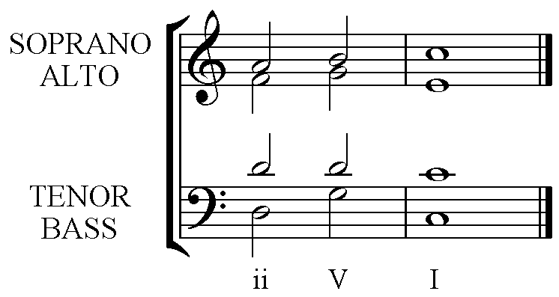 | 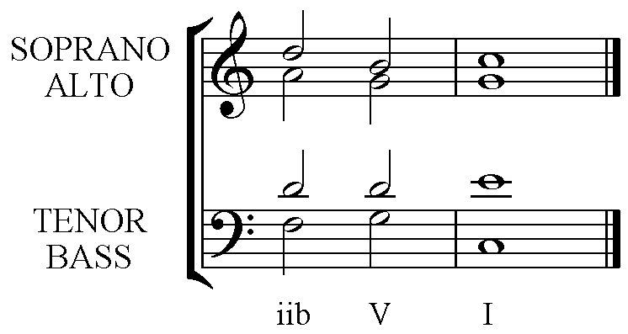
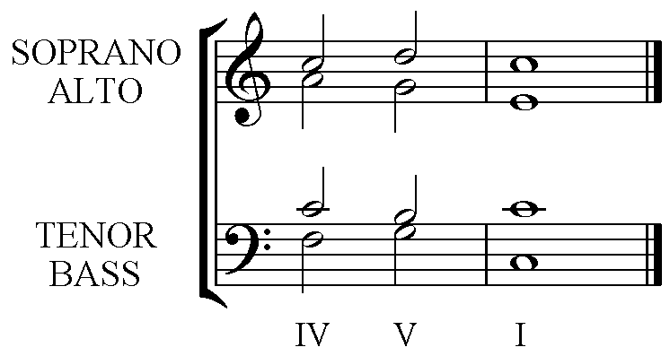 | 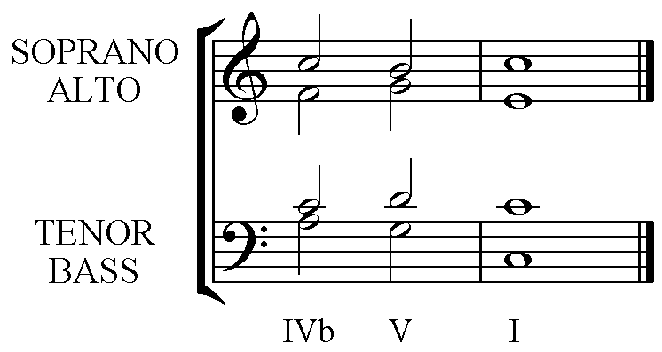
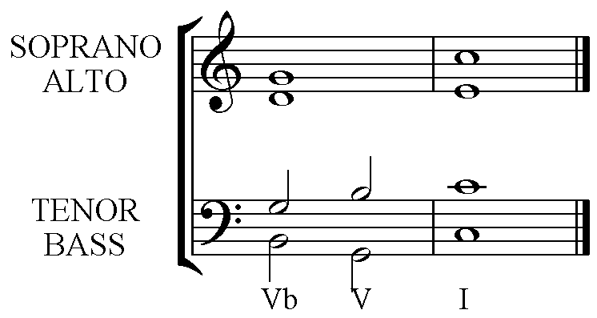 | 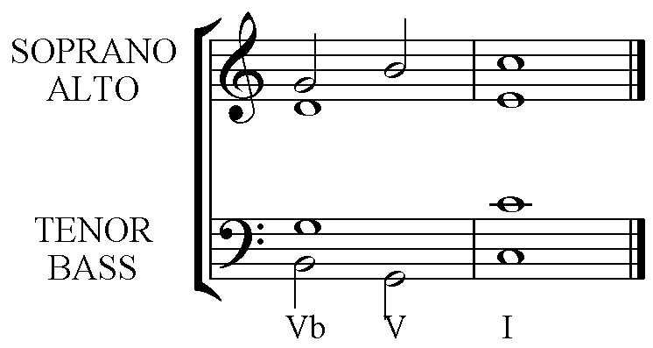

ii – V – I has a strong Bass line due to the leaps. This gives a bold harmonic change.

iib – V – I has a smoother Bass line as does IVb – V – I as the initial movement is by step, similarly IV – V – I.

Vb – V – I is just a rearrangement of the chord allowing some movement, decorating the long note. Note that this can be used for a sustained soprano note just as effectively as a moving one.

There are more possibilities for the chord before the Perfect Cadence, but these give the best results at this stage.

