Traditional four part vocal harmony

Stock Phrases

Melody moves by a 3rd.
Using the same chord for both pitches is frequently the best solution. Make sure that the 3rd of the chord is present in both chords, and that if the chord is Major that the 3rd is not doubled at any moment.
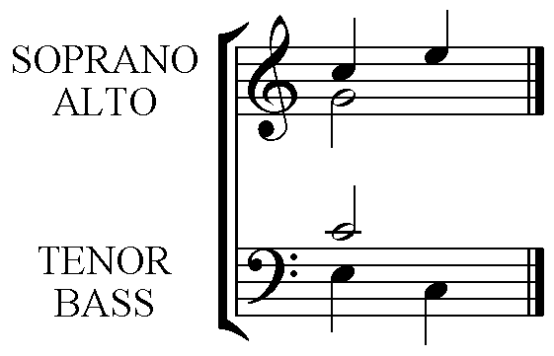

Or

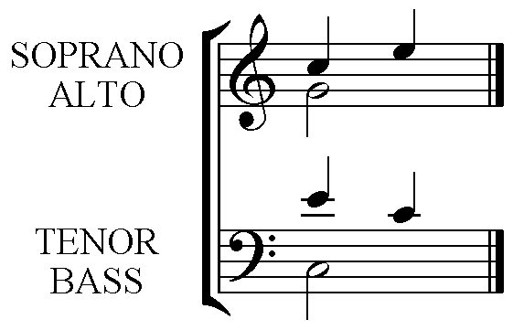

The use of chord viib in a three-chord sequence.

Examine the following:-

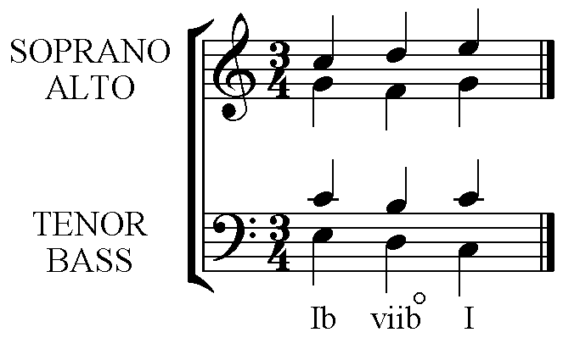
Notice:-
- All voices are moving smoothly by step.
- The diminished chord is used correctly in 1st Inversion and with the D (the 3rd of the Root position chord and now the Bass note) doubled.
- Two voices are moving by step in contrary motion – the Soprano and Bass voices in this example.
- Two voices, Tenor and Alto, are moving by step in 5^{ths} quite correctly as the 5th between B and F is a Diminished 5th and not a Perfect 5th as those between C and G.
- This sequence or its reverse can be used if the melody is any of the following:- Scale degrees:- 1 2 3 or 3 2 1 or 1 7 1 or 5 4 5. The Bass will either be 3 2 1 or 1 2 3. See below.

