Music Studies 2023 Answers / Suggested answers

- a. Example 2
b. Example 4
c. Example 2
d. Example 3
e. Example 1

- a. (i) Bbmaj7 OR B¨²
(ii) 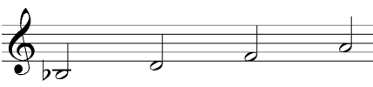
b. (i) G Augmented OR Gç OR G+ OR G#5
(ii) 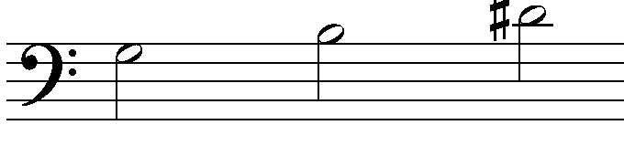

- a. Example 2 (F# harmonic minor)
b. Example 4 (A Dorian)

- a. Given
^ ^ ^ ^
As played
b. 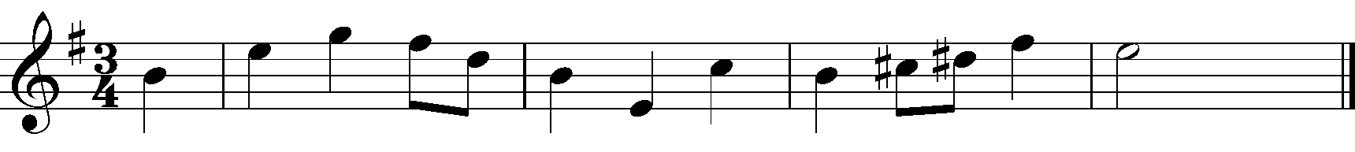
6. A simple balanced melody uses as much material from the original as possible, The modulation to the dominant C major at the end of the given phrase suggests that Bar 5 should begin in C major, Rests for the remainder of bar 4 would also be acceptable.
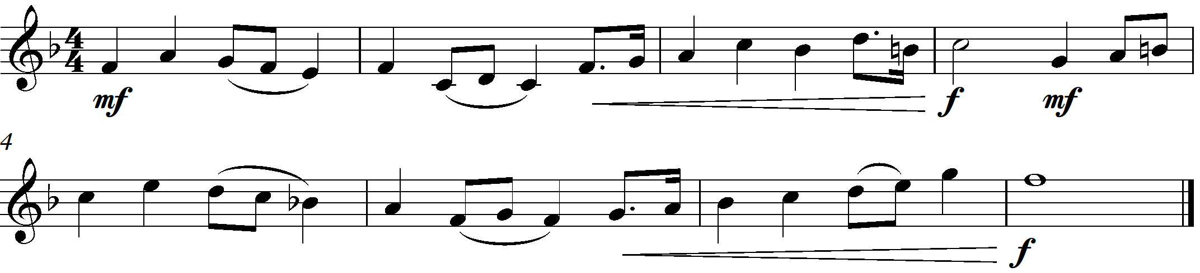
- a. C# dim OR C# º Or C#mb5
b. EbMajor Plagal cadence
c. Any 3 of the following
Crescendo to forte – gradually louder to loud
Poco accel – a little accelerated also with shorter note values so that it feels faster
Rising pitch
Poco rit – a little held back
Pauses on the two climax pitches – Hold for longer to achieve a dramatic effect
d. The circle of 4ths 1, 4, 7, 3, 6, 2, 5, 1.
e. First example – Sequence
f. G major ( 2 – 5) Imperfect cadence

- a. First example – Through composed
b. The texture varies from a single staccato repeated broken chord pattern to a melody of long notes accompanied by the rhythmic groove. Finally two homophonic chords to end.
c.
Minimalist style – use of the ostinato broken chord pattern and the repeated chords. The inclusion of a Balanese Gong suggest an Asian influence.
Techno style at the point where the drums enter.
Gregorian chant style vocals
Hymn like final two chord cadence voicing

- a. Time signature changed to 4/4 simple quadruple. Changed from 6/8 compound duple. One bar becomes 2 bars.
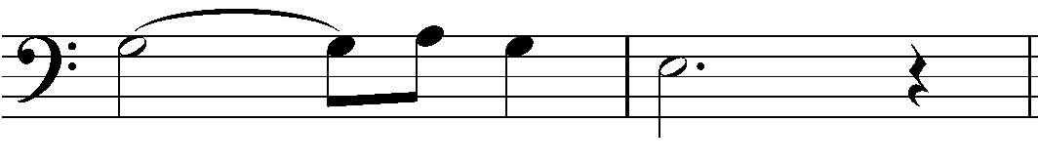
b. Submediant
c.
Bar numbers | Instrument
1 – 4 | Trombone
5 – 8 | French Horn
9 – 12 | Trumpet 2
13 – 16 | Tuba
d. (i) Staccato – play short and detached
(ii) Pause – hold for longer than the notated value
e. French Horn
10. a. Variation 1 is changed in these ways. Choose any 3
- Tempo is faster – Marked Allegretto [Theme marked Largo – meaning slow]
- The accompaniment is pianissimo (very soft) throughout
- The rest bars 1 and 3 in the accompaniment to the theme have been replaced with crotchet chords on beats 2, 3 and 4.
- The theme is played by the Tenor Saxophone – lower pitch than the original Soprano saxophone in the theme.
- Variation 1 is in the relative minor key
b. Variation 2 is changed in these ways. Choose any 3
- Tempo is slower than Variation 1 but faster than the opening theme. Andante – at an easy walking pace
- The instruments enter one at a time in imitation [with starting pitches:- F#, D, B , G spelling G²(G maj7) in reverse]
- Polyphonic texture in contrast to the simply accompanied melody of the theme
- All entries are marked leggiero meaning lightly and mp meaning moderately soft
- In the tonic key of G major
- Semiquavers feature giving a sense of movement
c. Variation 3 is changed in these ways. Choose any 3
- The melody returns to the soprano saxophone, this time with two trills (shake between the note and the one above) and one turn which as the name suggests the pitch turns about the given note first stepping above, returning to the notated pitch, stepping below before finally returning to the notated pitch.
- The accompaniment features quaver triplets that mostly feature broken chords [or arpeggios]. These are heard constantly until the final cadence. Only one instrument at a time has the triplets which are shared by all accompanying instruments. [Some use of the original accompanying figures from the theme in those instruments not having the triplets]
- Maestoso meaning majestic – the character is changed.
- The melody and the triplet accompaniment are marked mf – moderately loud. Other accompany lines are marked mp – moderately soft similar to the theme, until the final cadence which continues the mf in all parts.
d. Oblique motion is found in bar 11 where the Tenor Saxophone moves against the repeated pitches of the other instruments
e. Example 2 - minor 3rd
11. The following is a suggested answer
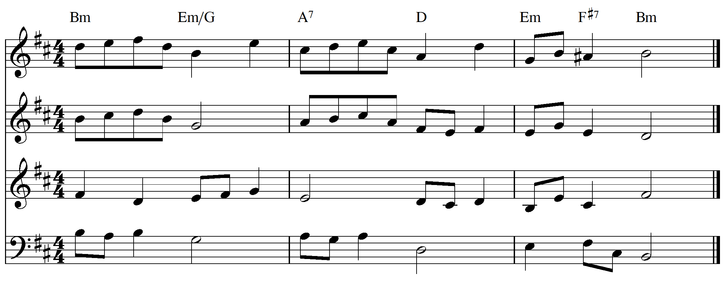
12.
13. Option A
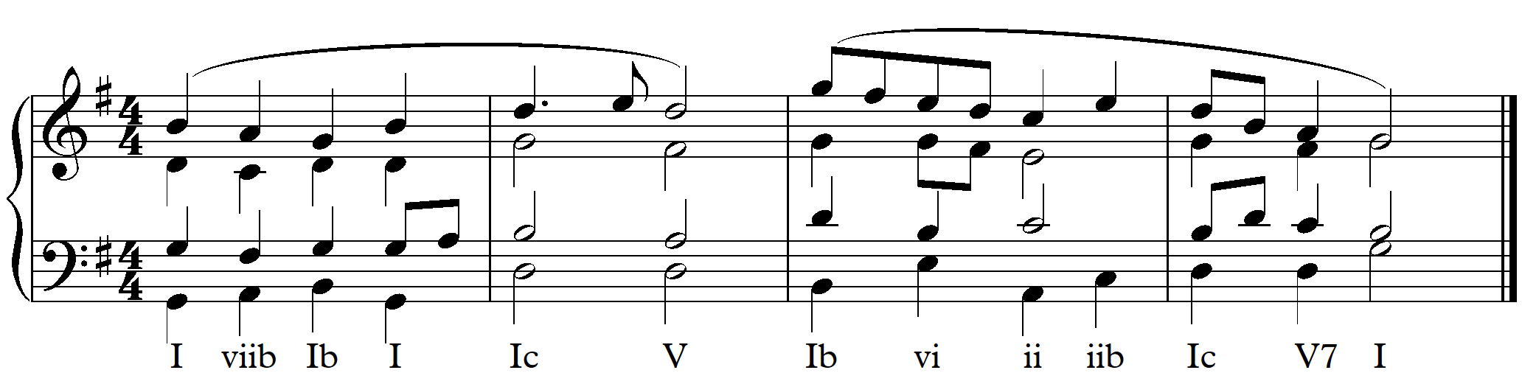
Option B
