Adding three parts to a given melody with chords.

Examine the melody and chords
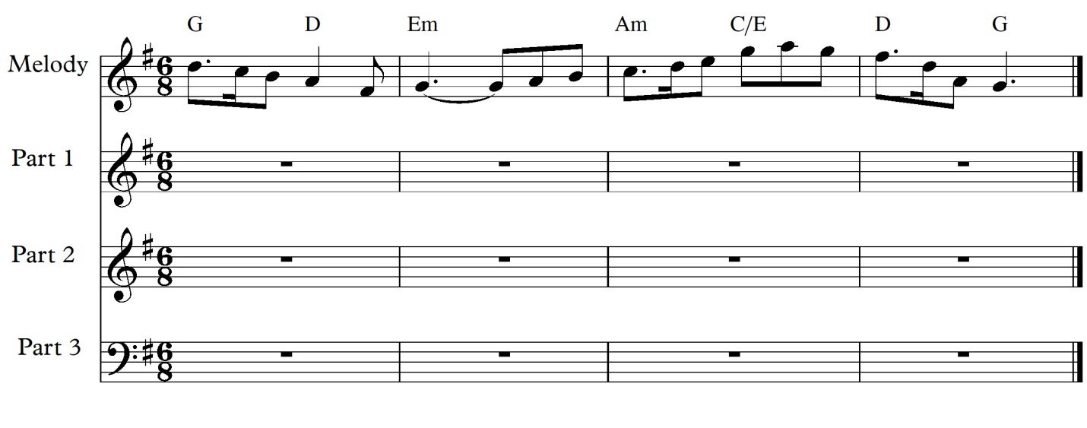
- Notice the key and given chords.
- Look for a place or places to add chord extension at least to the 7th
- Check the rhythms used. These rhythms should guide you in your added parts
- Consider the use of chord notes and non chord notes
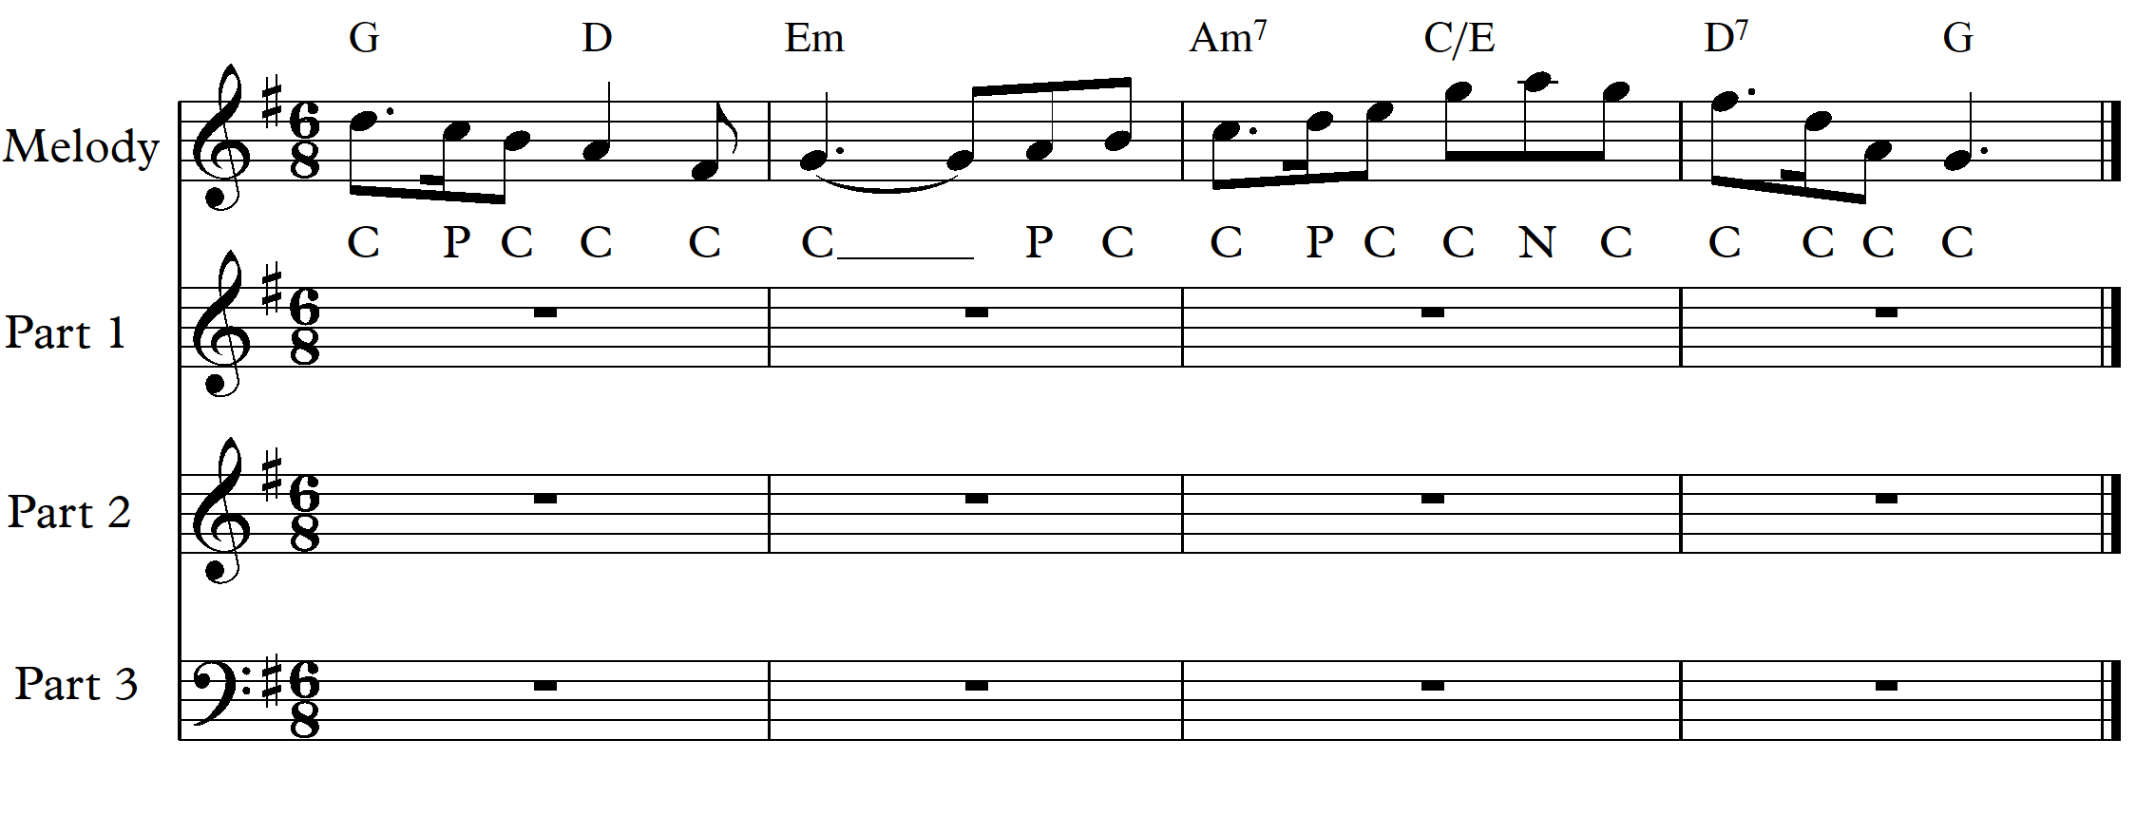
- The Am which is chord 2 (II) and the D, chord 5 (V the dominant) both are possible for chord extensions to the 7th.
  - Keep in mind that the 7th note when added will fall by step to the next note in that part.
- Mainly chord notes have been used, with three passing notes (P) and one neighbour note (N)
  - Non chord notes can be harmonized if moving in parallel motion, or doubled if moving in contrary motion.

Adding the Bass
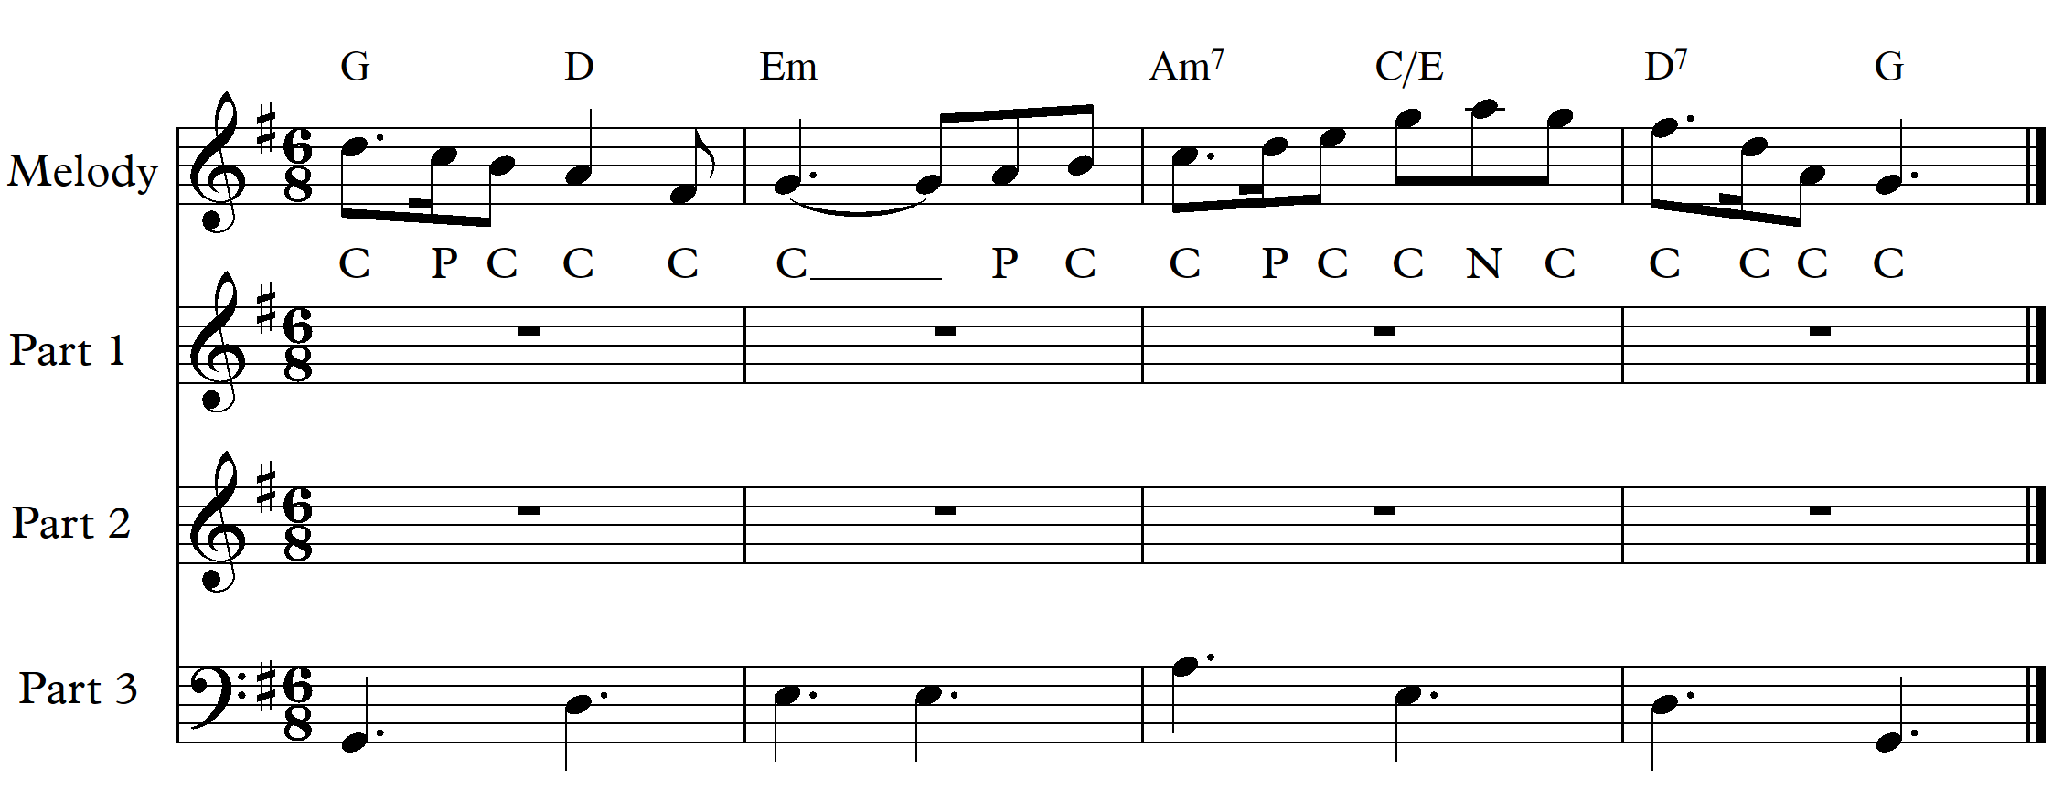
- The bass notes should be added first. These should be the root notes of the chords or the given bass as found in slash chords such as C/E where E is the bass. These notes should remain on the beat in your final answer.
- This part can be ‘dressed up’ with some non chord notes. Use one or more of the rhythmic elements of the given melody.

Dressing up the Bass
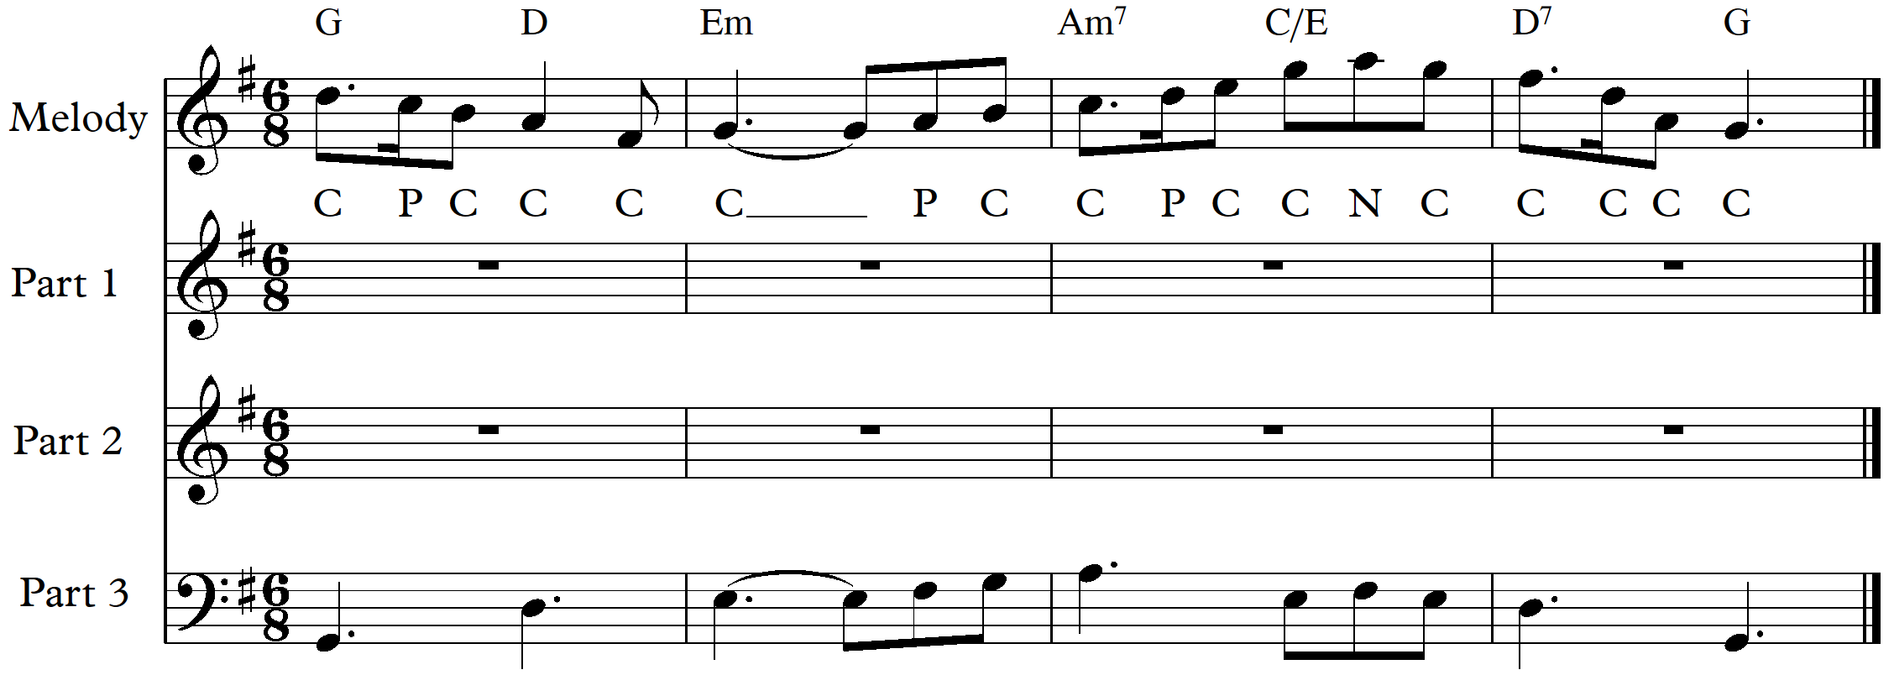
There are two ways of working next.
- Either one part, best if it is Part 1 so that the given melody can be supported closely below while allowing for space for part 2.
- OR both part 1 and 2 are worked together bar by bar.

Adding Part 1 to support the melody
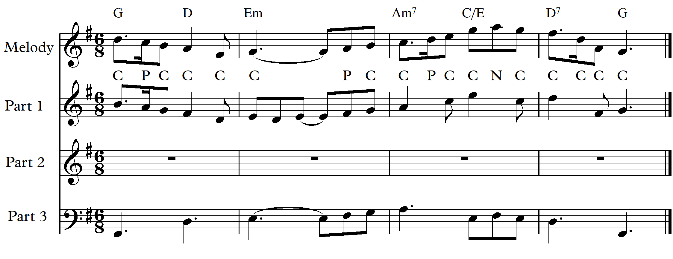
- Notice that Part 1 has 2 passing notes and one neighbour note.
- The rhythmic elements have been taken from the given melody.
- Beat 1 of bar 2 has movement when the melody remains on the sustained G

Completing the chords with part 2
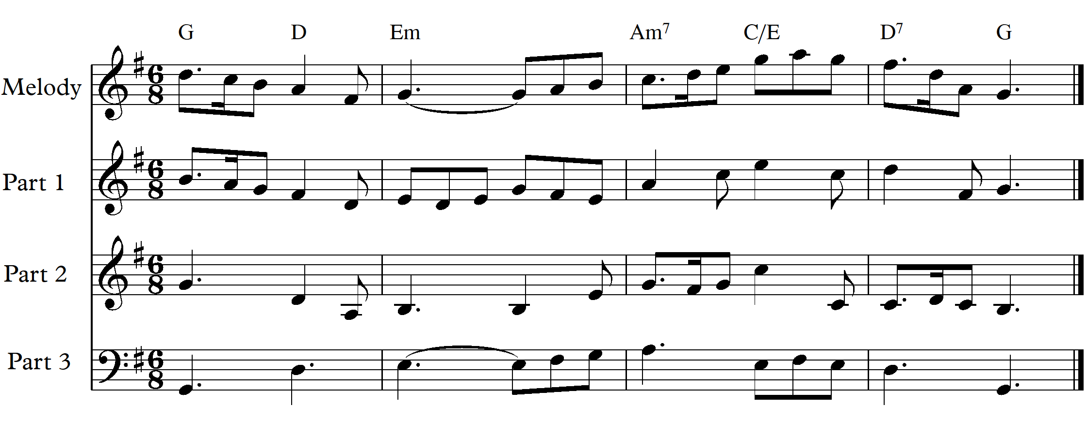
- Part 2 on this occasion mainly completed the chords. Only two neighbour notes have been added.

Checking
Checking should happen as you progress through the answer, but it is best to do a final thorough check.
- The final tasks – checking for:-
  - Parallel 5th and octaves. Remember that non chord notes can make parallel 5th or octaves and that their inclusion does not hide parallel 5th or octaves.
  - Correct spelling of all chords.
  - Correct doubling of chord notes.
  - The 3rd of the chord is present in all chords. (All parts with the tonic may be possible for the final chord only.)
  - Movement of any 7th of chords downwards to the next pitch in that part

