Music Studies 2021 Possible Answers
These answers are not approved by SACE. They have been put together by Dr Virginia Lakeman as a guide to teachers and students. Accompanying these written answers are Sibelius files of the creative and harmony questions. Where a variety of answers are possible each has been over answered. Students are encouraged to give as many points as there are marks allocated to the question.
- (a) Option 2
(b) Option 4
(c) Option 3
(d) Option 2
(e) Option 1
2. 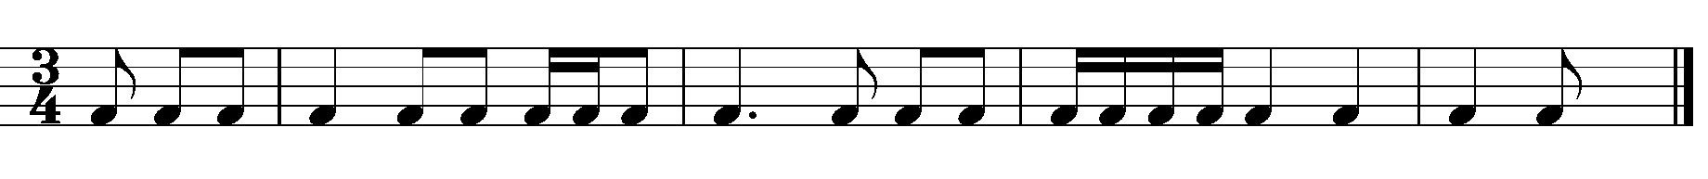
3. (a) Major 2nd (or tone)
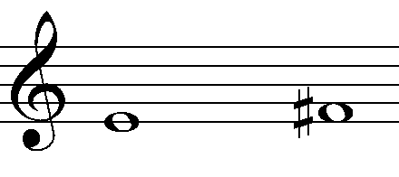
(b) Diminished 5th or Tritone
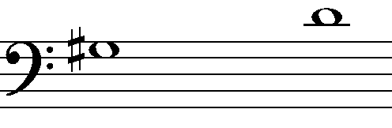

4. (a) Option 3
(b) Option 4

5. 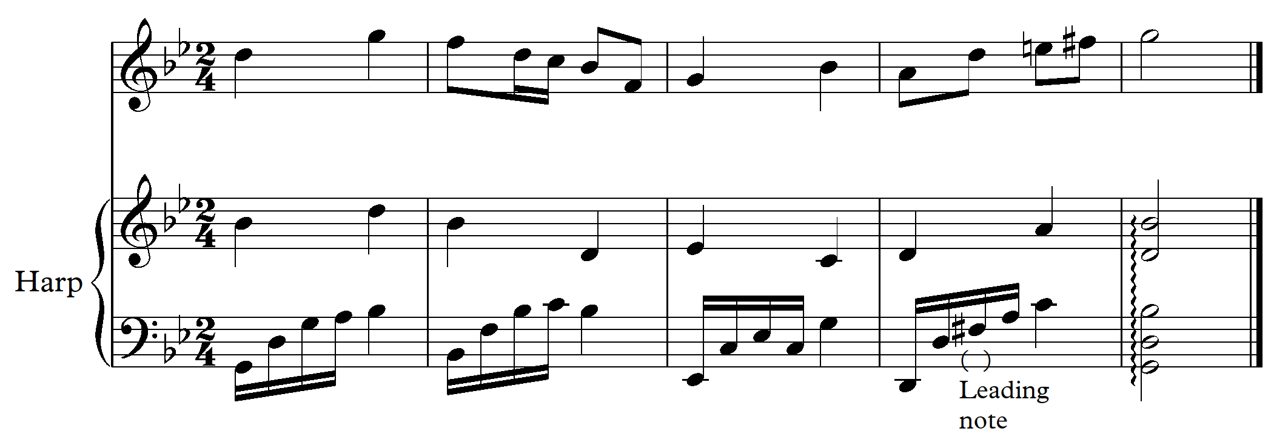

- Perfect cadence in G minor D7 to Gm.
- F# marked in bar 4
6.
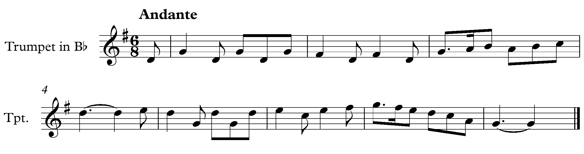

7. (a)
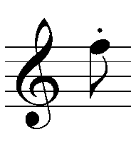 Staccato – short and detached 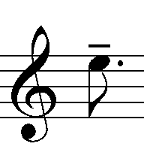 Tenuto – hold for the full value
(b) (i) Imitation where the clarinet part is a copy of the oboe part an octave lower.
(ii) The first dotted crotchet beat is as it was in bar 1 followed by the same pattern in
sequence down a 2nd.
(iii) Descending sequence
(c) Pedal point on the tonic B as quavers
- Em/G#
- The climax is reached in bar 13. The rising semiquaver from the oboe in bar 12, in contrary motion with the clarinet coupled with the cresc (crescendo – gradually louder) from bar 10 leading to ff (fortissimo – very loud). The rising and accented bass line culminating in the move from the leading note to tonic. (A# to B).
(f)
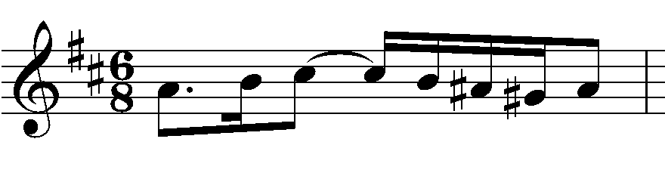

8. (a) Option 2 - Ternary – (quite long opening section with various elements – contrasting Jazz influenced middle section followed by a shortened return of the opening material which is finally treated as a short coda featuring repetition at lower octaves.)
(b) (i) Rhythm and meter. The opening features rapid almost ostinato figures with accents and syncopation with a feeling of 2 in a bar. This contrasts with the Jazz swing influenced middle section which has an improvise feel with varied subdivisions of the beats and a clear 4 beats per bar.
(ii) Texture. The opening section has slight changes in texture beginning with a left hand single notes and the right with slightly accented and syncopated chords. This is followed by a simpler accompaniment maintaining the same subdivision of beats when the right hand takes a fast moving melody. - Accompanied melody. A variation in this section features parallel motion in 3rds in the right hand and between hands. The Jazz influenced middle section has a more varied approach to texture, some chordal, with the melody in the upper pitches, some monophonic melodic ideas. Both have short rapid upward inflections that lead into some new bars.
(iii) Tonality The opening and final section feature a minor pentatonic and largely centered in one tonal centre and using chords in close position with added 2nds. The contrasting middle section uses jazz harmony techniques and is major using typical extended chords and 2 – 5 – 1 progressions to colour the harmony.
9. (a) The simple duple (6/8) has become simple quadruple (4/4) with the crotchet quaver becoming a dotted minim crotchet. Resulting in half a bar in the original has become a full in the arrangement. Demisemi quaver figures have replaced the more simple dotted quaver – semiquaver-quaver patterns of the original beat 2 of bar 1 and following. The first beat of bar 2 becomes a triplet with the final crotchet tied to beat 3 in the arrangement.
(b) Am add9, Ab, Am add9 Ab, G add9 G, G add9 G, Fmaj7 Fmaj7/C, Am add9 Am/E, E add9.
Am add9 Fmaj7/A C, C add9/G C, G add 9 G, G, (bar 19) E, E, Am
Simply:- added 9ths on the beat are frequently used, resolving to a major triad in most cases – Am add9 to Ab and G add9 to G. F maj7 moves to C. The final cadence is a simple perfect cadence 5 – 1 (E – Am) in A minor.
(c) The trumpet and violin play supplying supporting harmony in rhythmic unison with the main melodic pitches that are played by the clarinet.
(d) (i) Mezzo staccato – moderately short and detached
(ii) Arpeggiate the chord by playing successive notes from lowest to highest.
(f) A grouplet where 5 notes are played in the time of one crotchet beat. OR 5 notes played in the time of 4 of the same written value.
10. (a) Dimitri’s dream has a monophonic melody with chordal (homophonic) staccato or in the case of
the strings, pizzicato chord interjections.
Waltz for Erica – accompanied melody
- Dimitri’s dream features changing meters, 4/4, 2/4, ¾, 5/4, and varied subdivisions of the beats in the melodic elements, including triplets and quintuplets as well as long held notes to end many phrases.
Waltz for Erica remains in ¾ throughout. The bass is mainly dotted minims to start each bar with the accompanying chords on beats 2 and 3. The shortest subdivisions of the beat in the melody are quavers. A tied minim to a quaver frequently begins the early and final bars.
- Dimitri’s dream
- Bar 28 Contrary motion between winds and strings
- Bars 20, 22, 25 varied repetition
- Bar 25 - 26 Viola and Cello have an inverted form of the clarinet in imitation

Waltz for Erica
- Bar 21 – 22 and 37 – 40 slow then return to the former speed. Bar 21 poco rall – a little gradually slower. Bar 37 – 39 Rit. Ritenuto – meaning immediately slower.
- Bars 1 – 4 An introduction to set the waltz three in a bar feel
- Bars 11 and 12 A two bar dead spot fill or musical comment at the end of the first melodic phrase using a chromatic 3rd chord of Ab from F and returning to F.
- Bars 1 – 2. Chromaticism Dm to D dim/F (There are other examples of Chromaticism.)

11.
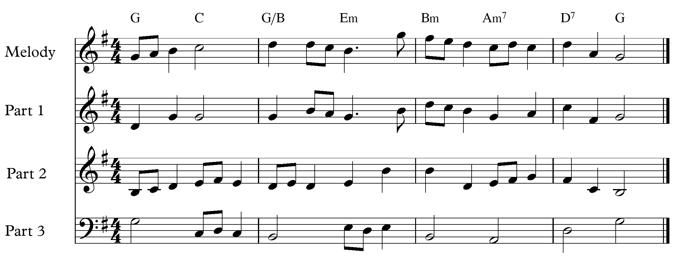
12.
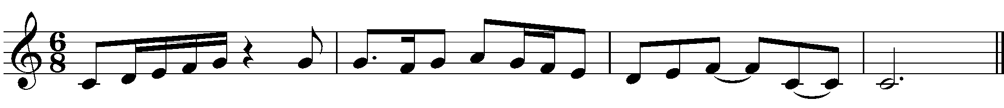
13. Two possible versions are given. Required:- a cadential six-four chord and a dominant seventh.
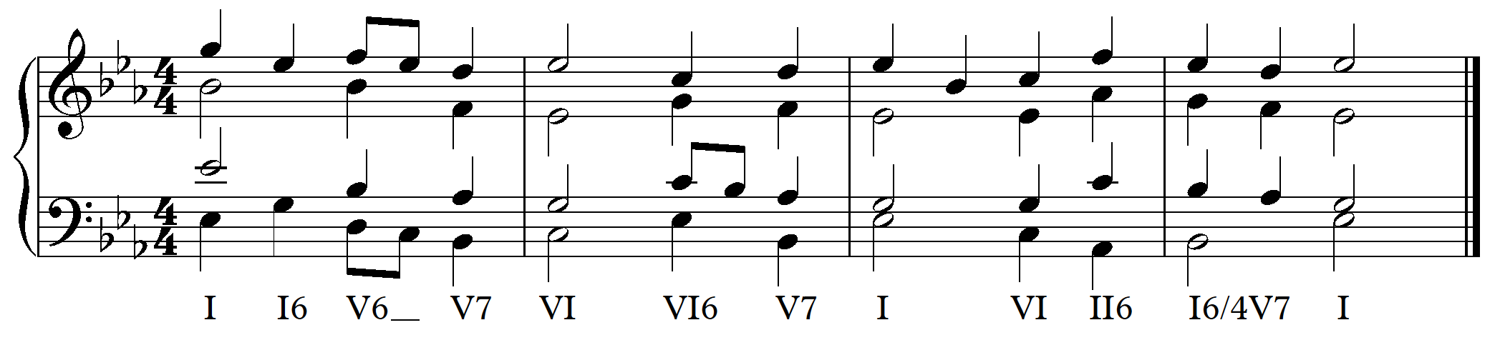

Jazz harmony with two secondary dominants, at least one alteration and at least one extended chord

